**IDEA** 实战

# IDEA 介绍

## IDEA 简介

IDEA 全称 IntelliJ IDEA，是用于 java 语言开发的集成环境（也可用于其他语言），IntelliJ 在业界被公认为最好的 java 开发工具之一，尤其在智能代码助手、代码自动提示、重构、J2EE 支持、Ant、JUnit、CVS 整合、代码审查、创新的 GUI 设计等方面的功能可以说是超常的。 IDEA 是 JetBrains 公司的产品，这家公司总部位于捷克共和国的首都布拉格，开发人员以严谨著称的东欧程序员为主。

对于 IDEA，JetBrans 公司提出的最新口号是：Capable and Ergomomic IDE for JVM ,翻译过来就是面向 JVM、功能强大且符合人体工程学的 IDE。面向 JVM 的是指该 IED 支持 Java、

Scale 等运行于 JVM 之上的所有语言。

## IDEA 版本说明

IDEA 共分为两大版本

商业版：旗舰版功能强大免费版：社区版功能单一

## IDEA 特点

所提倡的是智能编码，是减少程序员的工作

### 智能的选取

在很多时候我们要选取某个方法，或某个循环或想一步一步从一个变量到整

个类慢慢扩充着选取，IDEA 就提供这种基于语法的选择，在默认设置中 Ctrl+W，可以实现选取范围的不断扩充，这种方式在重构的时候尤其显得方便。

### 丰富的导航模式

IDEA 提供了丰富的导航查看模式，例如 Ctrl+E 显示最近打开过的文件，Ctrl+N 显示你希望显示的类名查找框（该框同样有智能补充功能，当你输入字母后 IDEA 小风 Java 实战系列教程将显示所有候选类名）。在最基本的 project 视图中，你还可以选择多种的视图方式。

### 历史记录功能

不用通过版本管理服务器，单纯的 IDEA 就可以查看任何工程中文件的历史记录，在版本恢复时你可以很容易的将其恢复。

JUnit 的完美支持

### 对重构的优越支持

IDEA 是所有 IDE 中最早支持重构的，其优秀的重构能力一直是其主要卖点之一。

### 编码辅助

Java 规范中提倡的 toString()、hashCode()、equals()以及所有的 get/set 方法，你可以不用进行任何的输入就可以实现代码的自动生成，从而把你从无聊的基本方法编码中解放出来。

### 灵活的排版功能

基本所有的 IDE 都有重排版功能，但仅有 IDEA 的是人性的，因为它支持排版模式的定制，你可以根据不同的项目要求采用不同的排版方式。

XML 的完美支持 xml 全提示支持：所有流行框架的 xml 文件都支持全提示，谁用谁知道。

### 3.7动态语法检测

任何不符合 java 规范、自己预定义的规范、累赘都将在页面中加亮显示。

### 3.8代码检查

对代码进行自动分析，检测不符合规范的，存在风险的代码，并加亮显示。

### 3.9对 JSP 的完全支持

不需要任何的插件，完全支持 JSP。

### 智能编辑

代码输入过程中，自动补充方法或类。

### EJB 支持

不需要任何插件完全支持 EJB(6.0 支持 EJB3.0)

### 列编辑模式

用过 UtralEdit 的肯定对其的列编辑模式赞赏不已，因为它减少了很多无聊的重复工作，而 IDEA 完全支持该模式，从而更加提高了编码效率。

### 预置模板

预置模板可以让你把经常用到的方法编辑进模板，使用时你只用输入简单的几个字母就可以完成全部代码的编写。例如使用比较高的 public static void

main(String[] args){}你可以在模板中预设 pm 为该方法，输入时你只要输入 pm 再按代码辅助键，IDEA 将完成代码的自动输入。

### 完美的自动代码完成

智能检查类中的方法，当发现方法名只有一个时自动完成代码输入，从而减少剩下代码的编写工作。

### 版本控制完美支持

集成了目前市面上常见的所有版本控制工具插件，包括 git、svn、github，让

开发人员在编程的工程中直接在 intellij idea 里就能完成代码的提交、检出、解决冲突、查看版本控制服务器内容等等。

### 不使用代码的检查

自动检查代码中不使用的代码，并给出提示，从而使代码更高效。

### 智能代码

自动检查代码，发现与预置规范有出入的代码给出提示，若程序员同意修改

自动完成修改。例如代码：String str = "Hello Intellij " + "IDEA"; IDEA 将给出优化提示，若程序员同意修改 IDEA 将自动将代码修改为：String str = "Hello Intellij IDEA";

### 正则表达式的查找和替换功能

查找和替换支持正则表达式，从而提高效率。

### JavaDoc 预览支持

支持 JavaDoc 的预览功能，在 JavaDoc 代码中 Ctrl+Q 显示 JavaDoc 的结果，从而提高 doc 文档的质量。 **3.20**程序员意图支持

程序员编码时 IDEA 时时检测你的意图，或提供建议，或直接帮你完成代码。

不需要再使用 CTR+S 不停的保存代码

# IDEA 安装

IDEA 版本：ideaIU-2017.3.1

## IDEA 官网

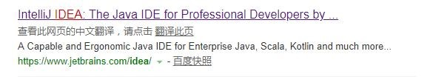

## 如何安装 IDEA

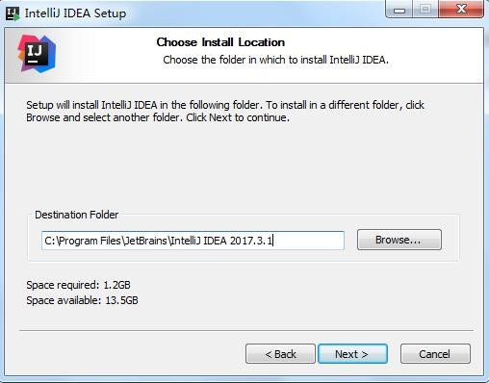

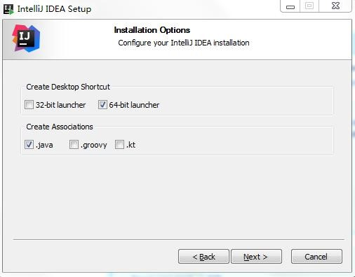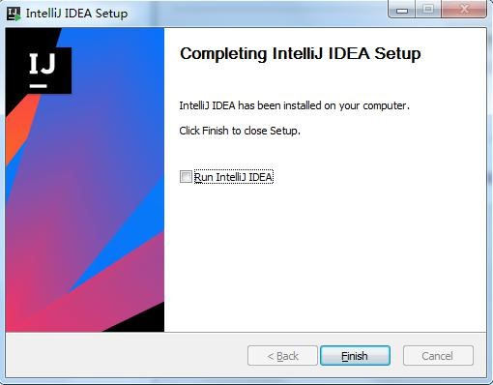

## IDEA 破解

### 将 jar 包拷贝到 idea 安装完毕的 bin 目录下

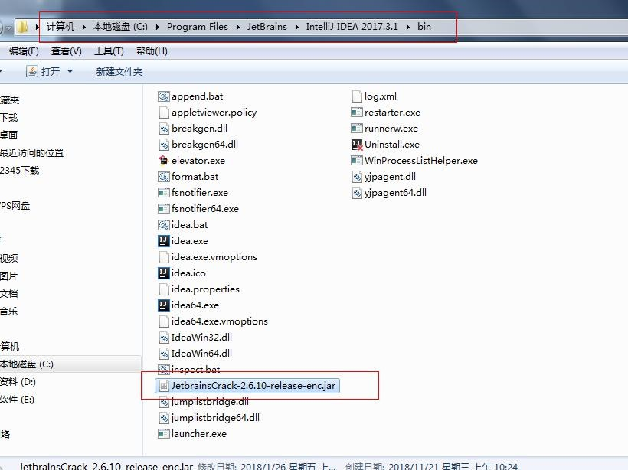

### 修改 idea 的 bin 目录下的配置文件

Idea.exe.vmoptions

Idea64.exe.vmoptions

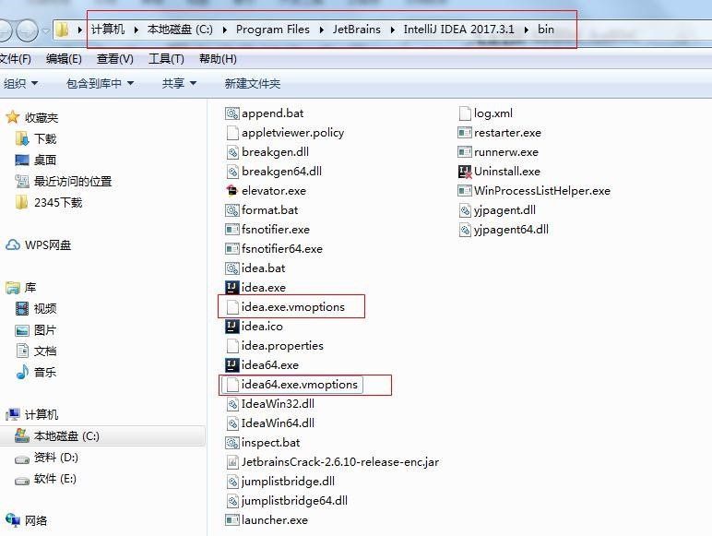

### 通过激活码，激活 Idea

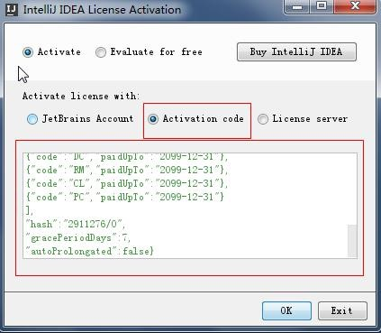

## 配置 IDEA

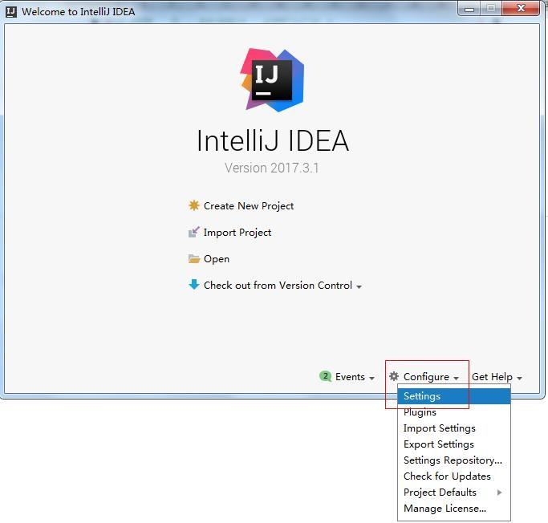

或者

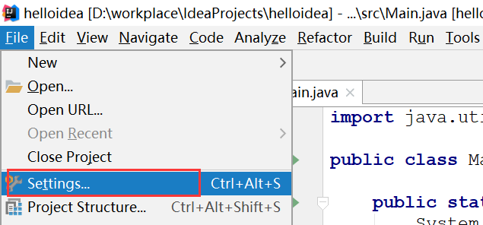

### 配置字体与大小

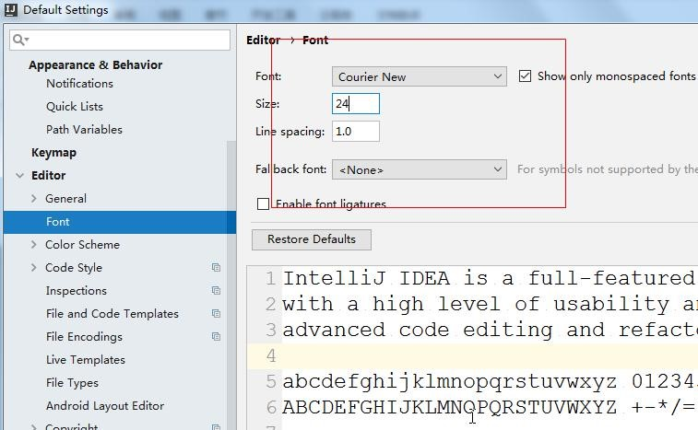

### 配置 Idea 的主题风格

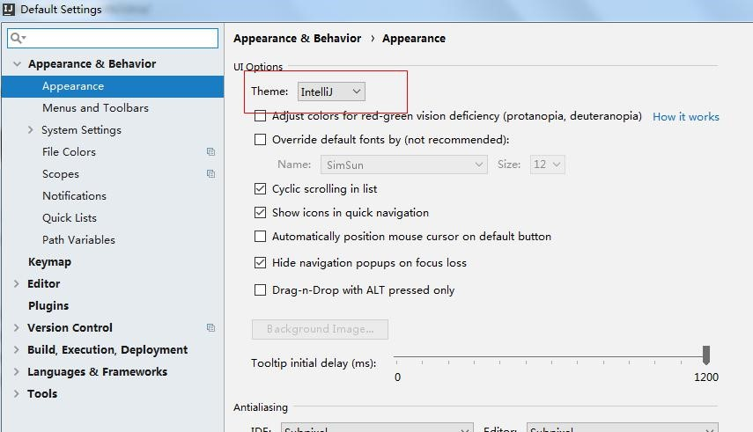

### 配置 Maven

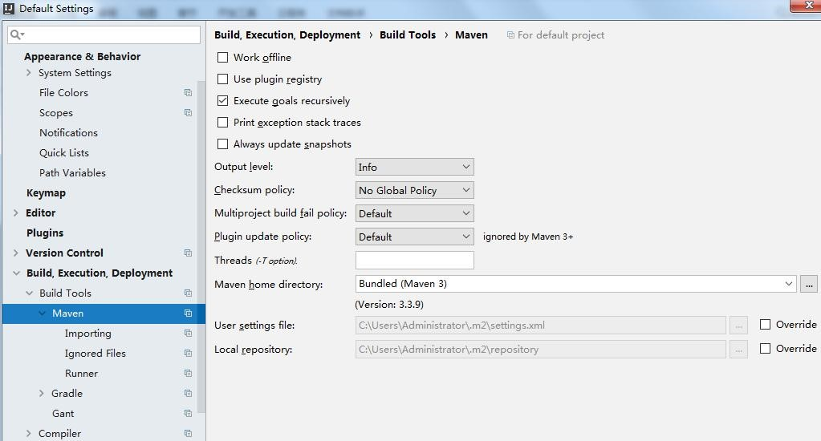

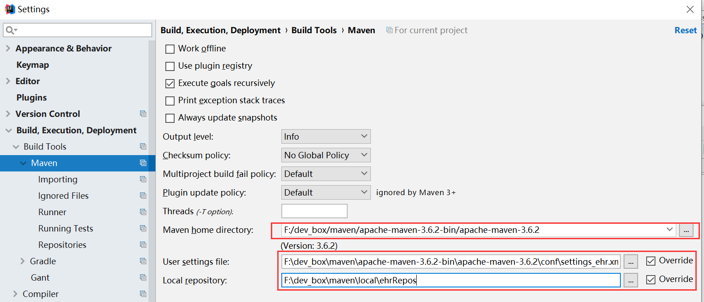

# IDEA 中的项目创建

## 创建 java 项目

### 启动时创建项目

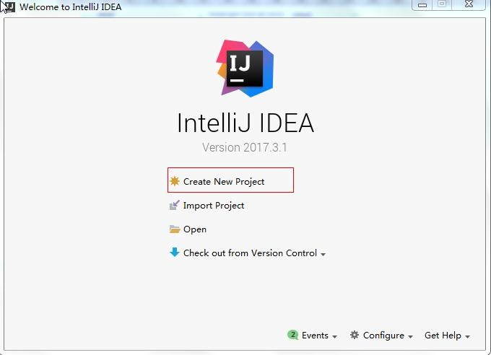

### 配置 JDK

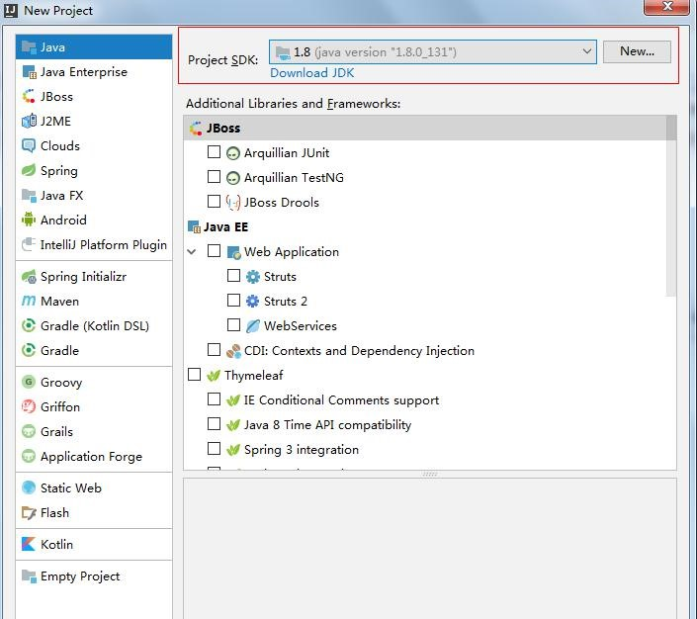

### 选择项目模板

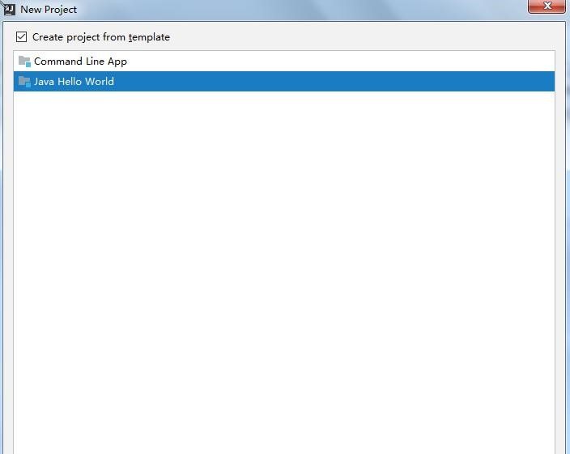

### 指定项目存放位置以及项目名称

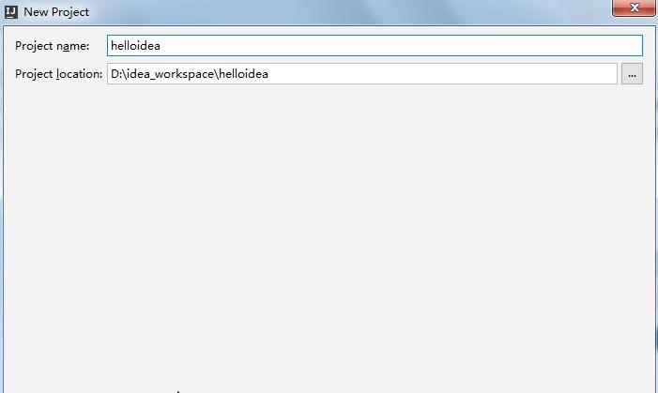

### 隐藏 IDEA 的项目配置文件

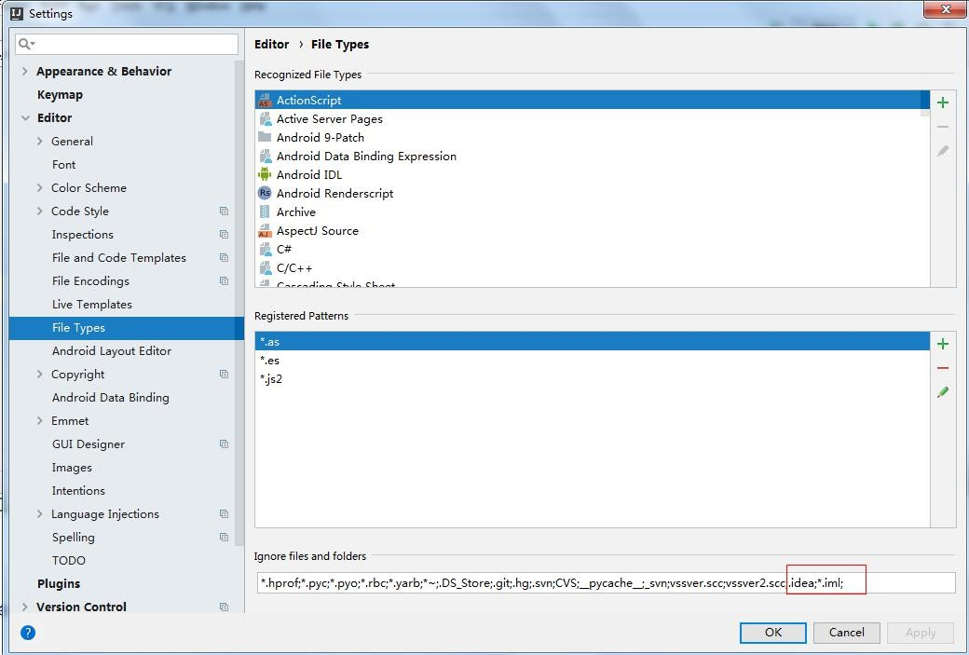

### Main 方法的运行方式

#### 点击菜单栏中的运行按钮

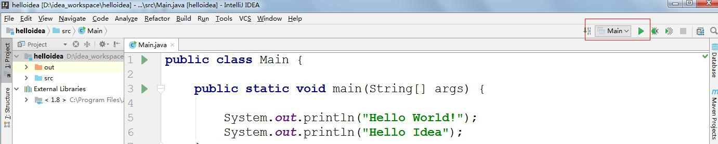

#### 点击鼠标的右键，通过菜单中的选项来运行

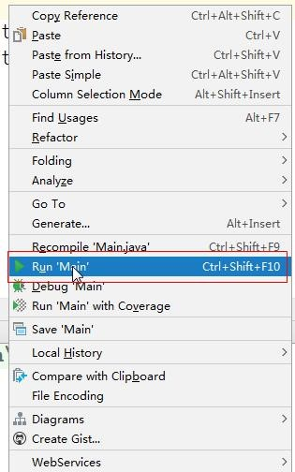

## 快捷键使用

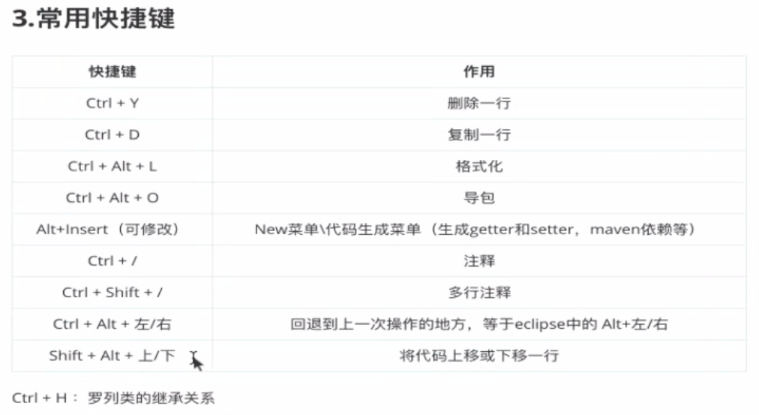

**2.1CTR+N** 搜索类

**2.2CTR+SHIT+N** 搜索文件

**2.3CTR+ALT+**空格代码提示（类似于 **ALT+/**）

**2.4ALT+F7** 查询在某处使用

**2.5CTR+Q** 查看代码提示及内容

**2.6CTR+B** 查看类的声明还可以直接按住：**CTR** 再点击鼠标

（和 **eclipse** 的用

**2.7**法是一样的）

**2.8CTR+F12** 查看文件列表（**File Structure**）

**2.9SHIFT+F6** 重命名。

**2.10ALT+INSERT :**生成 **getter** 和 **setter** 的方法

**2.11CTR+ALT+T** 选中某一个段代码进行 **try catch**

**2.12CTR+SHIT+**空格：新建类时在 **new** 后面使用（提示自动创建类）

**2.13CTR+ALT+B** ：查看接口或者抽象类的子类。

**2.14CTR+SHIT+/ :**注释（整体注释）

**2.15CTR+/ :**行注释

**2.16CTR+D :**换行并复制 **2.17CTR+Y :** 删除当前行

## 使用 Eclipse 方式的快捷键

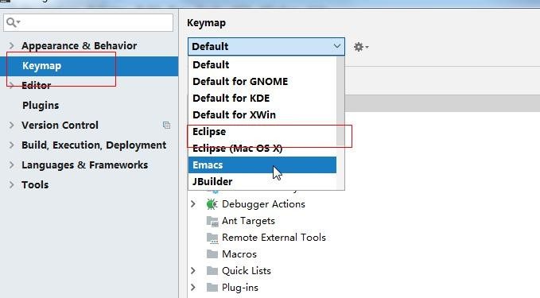

## 设置syso等类似的快捷键

1. 打开IntellJ IDEA，点击菜单的“File”->“Settings”，打开设置对话框。

[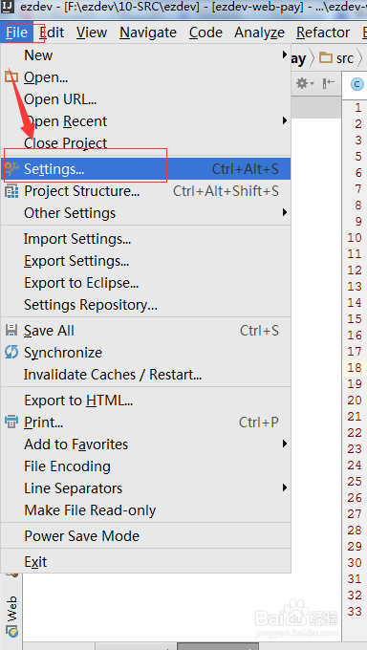](http://jingyan.baidu.com/album/f25ef254526790482c1b82ee.html?picindex=1)

1. 在对话框左上角的搜索框中输入：Live template，会列出相关的选项。

[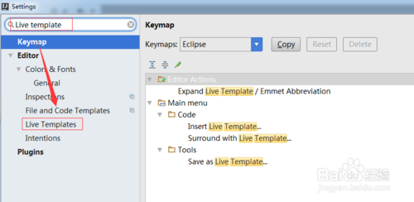](http://jingyan.baidu.com/album/f25ef254526790482c1b82ee.html?picindex=2)

1. 点击“Live Templates”菜单，在右边展开的面板中，找到output下面的sout。

[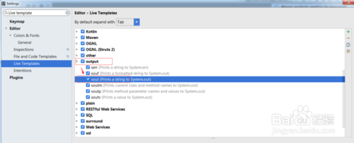](http://jingyan.baidu.com/album/f25ef254526790482c1b82ee.html?picindex=3)

1. 原来在idea中，syso被替换成了sout。我们只要把它替换回来就可以正常使用了。

[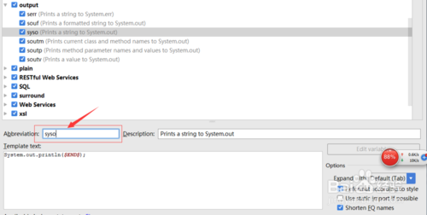](http://jingyan.baidu.com/album/f25ef254526790482c1b82ee.html?picindex=4)

1. 下面赶紧来测试下，在源文件任意地方键入：syso按回车就可以出现快捷键了。有木有很兴奋啊！

[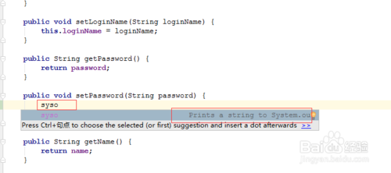](http://jingyan.baidu.com/album/f25ef254526790482c1b82ee.html?picindex=5)

1. main的快捷键在这里：

[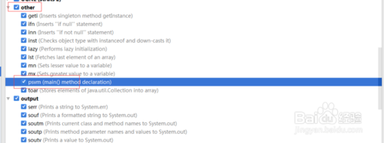](http://jingyan.baidu.com/album/f25ef254526790482c1b82ee.html?picindex=6)

## IDEA 中的代码模板

### 代码提示模板

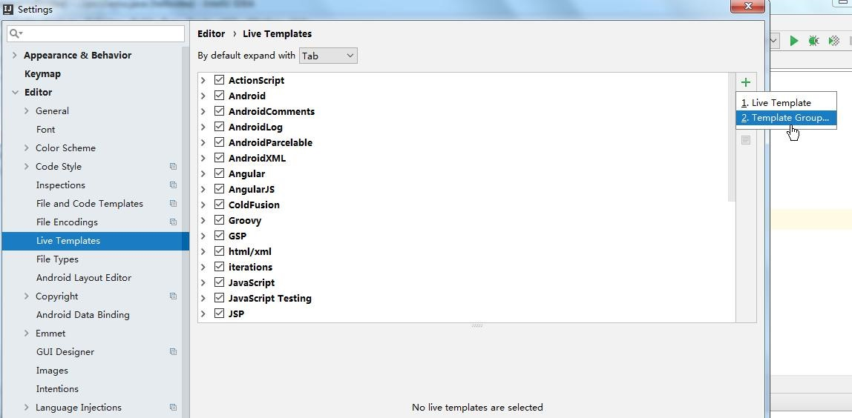

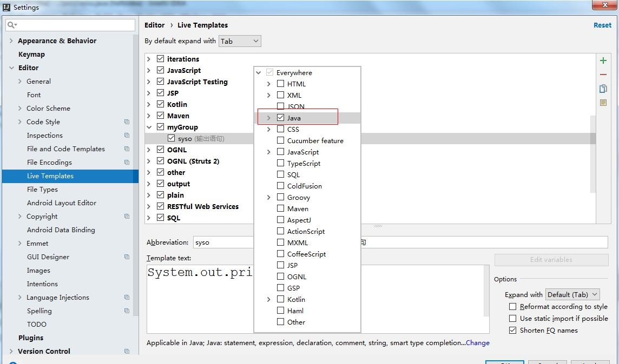

### 设置组件内容模板

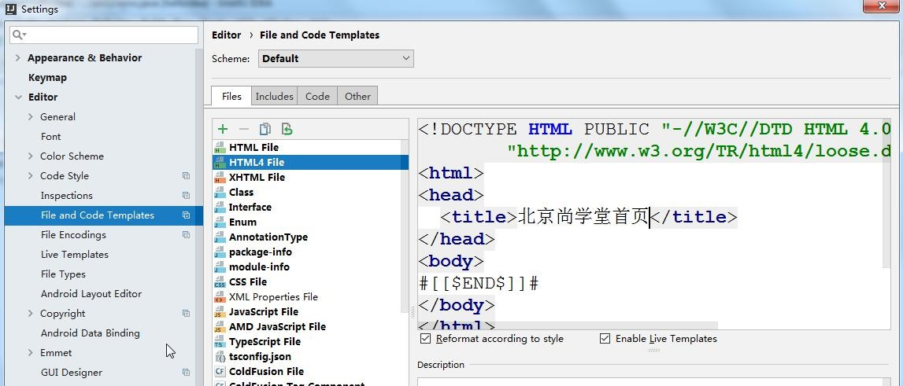

### 注释模板

#### 类注释模板

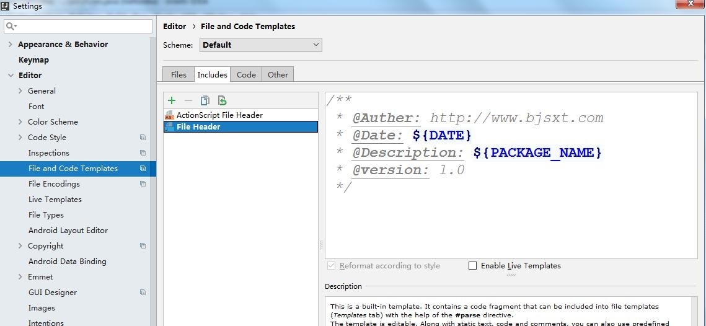

/**

* @Auther: http://www.bjsxt.com
* @Date: ${DATE}
* @Description: ${PACKAGE_NAME}
* @version: 1.0

*/

#### 方法注释模板

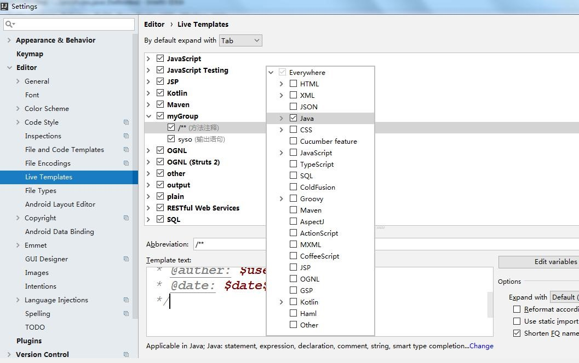

/**

* 功能描述:
* @param: $param$
* @return: $return$
* @auther: $user$
* @date: $date$ $time$

*/

## 创建 Web 工程

### 创建工程

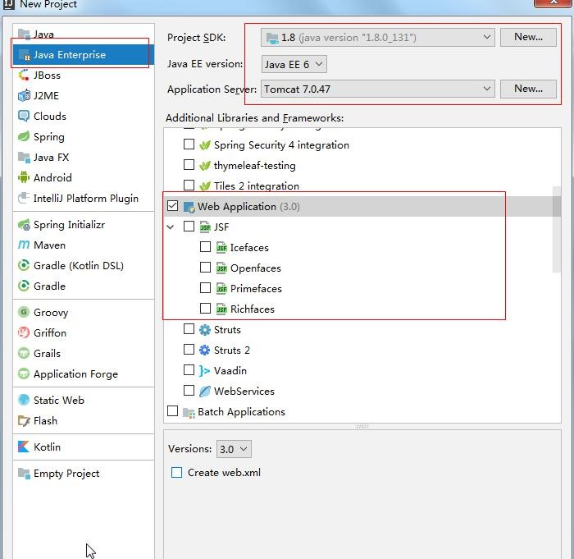

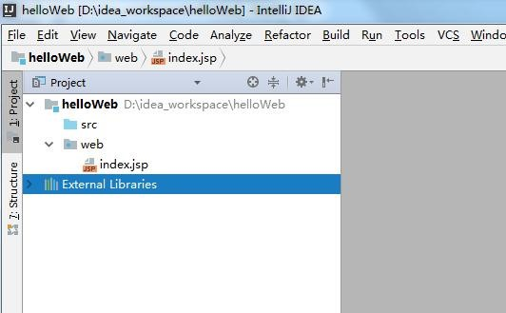

### 创建 jsp

|  |  |  |  |  |  |
| --- | --- | --- | --- | --- | --- |
| *<%--*  *Created by IntelliJ IDEA.*  *User: Administrator*  *Date: 2018/11/21 0021*  *Time:* 下午*4:06*  *To change this template use File | Settings | File Templates.*  *--%>* | | | | | |
|  | <%@ **page contentType**="**text/html;charset=UTF-8**" | | | | |
| |  |  |  |  | | --- | --- | --- | --- | | **language**="**java**" %> | | | | | <**html**> | | | <**head**> | | | | | | |
|  | <**title**> | 北京尚学堂 | </**title**> |  |
| |  |  |  | | --- | --- | --- | | </**head**> | | | | <**body**> | | | <**form action="addUser" method="post"**> | | |  |  | | --- | | <**input type="text"** |   用户名：   |  | | --- | | **name="username"**/><**br**/> |  |  | | --- | | <**input type="text"** |   年龄：<   |  | | --- | | **name="userage"**><**br**/> |  |  | | --- | | <**input type="submit" value="OKOK"**> |   <   |  |  |  | | --- | --- | --- | | </**form**> | | | | </**body**> | | | | </**html**> | | | | | | | | |

**5.3**创建 **Servlet**

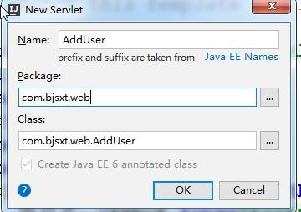

**5.4**去掉参数标记

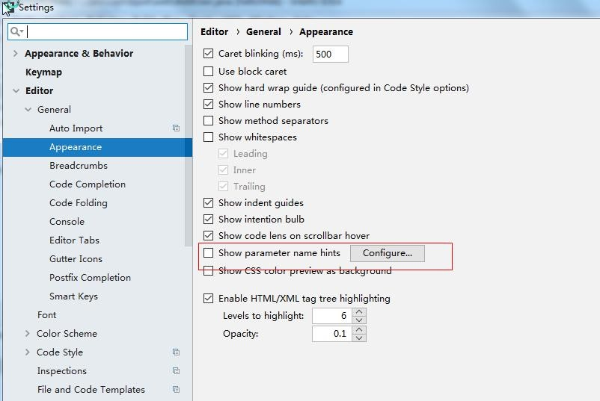

*/\*\**

* ***@Auther:*** *http://www.bjsxt.com \** ***@Date:*** *2018/11/21 0021 \** ***@Description:*** *${PACKAGE_NAME}*
* ***@version:*** *1.0*

*\*/* @WebServlet(name = **"AddUser"**,urlPatterns = {**"/addUser"**})

**public class** AddUser **extends** HttpServlet { **protected void** doPost(HttpServletRequest request, HttpServletResponse response) **throws**

ServletException, IOException {

|  |
| --- |
| request.setCharacterEncoding(**"utf-8"**);  String username =  request.getParameter(**"username"**);  String userage =  request.getParameter(**"userage"**);  System.***out***.println(username+**"**  **"**+userage); }  **protected void** doGet(HttpServletRequest  request, HttpServletResponse response) **throws**  ServletException, IOException {  **this**.doPost(request,response);  } } |

### 配置项目访问路径

#### 默认访问路径问 /

#### 修改访问路径

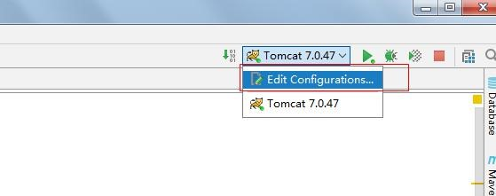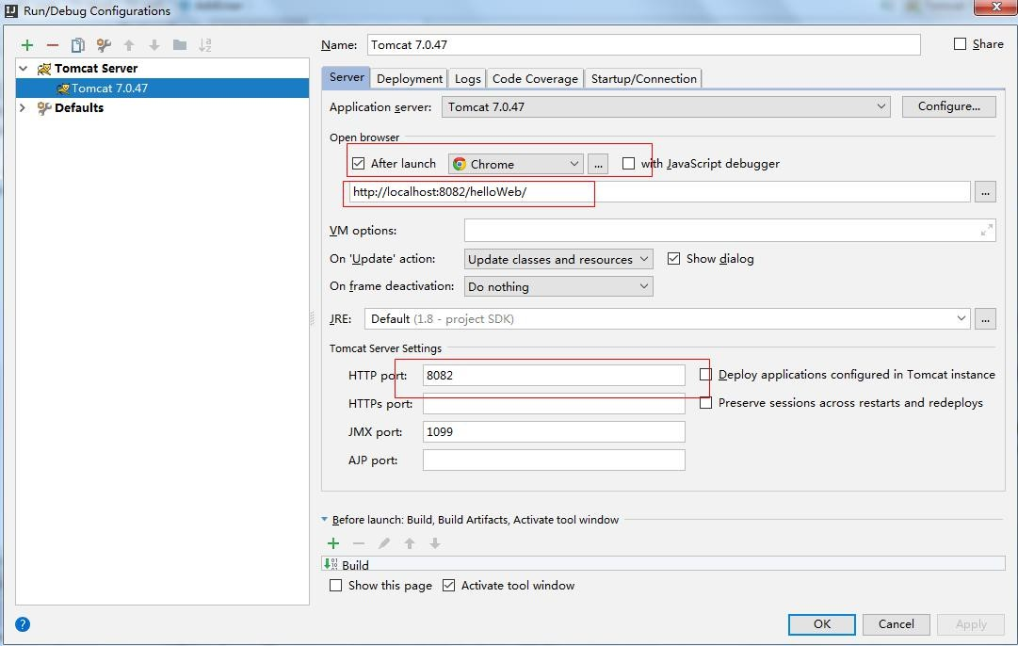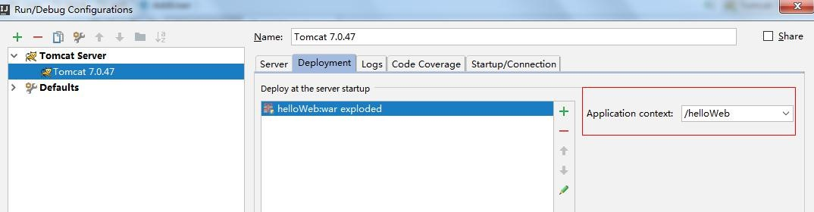

# 创建 Maven 项目

## 配置 Maven

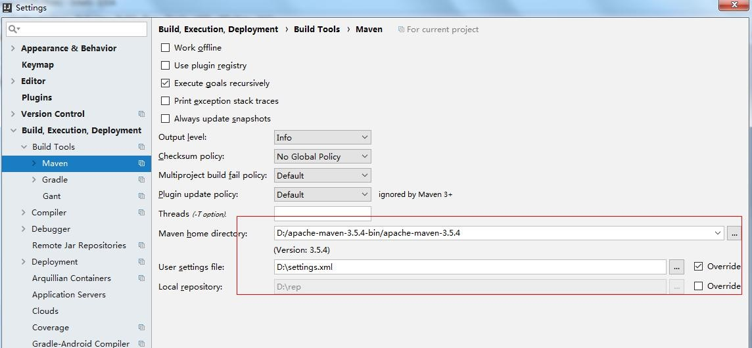

## 创建普通 Maven 项目

### 创建项目

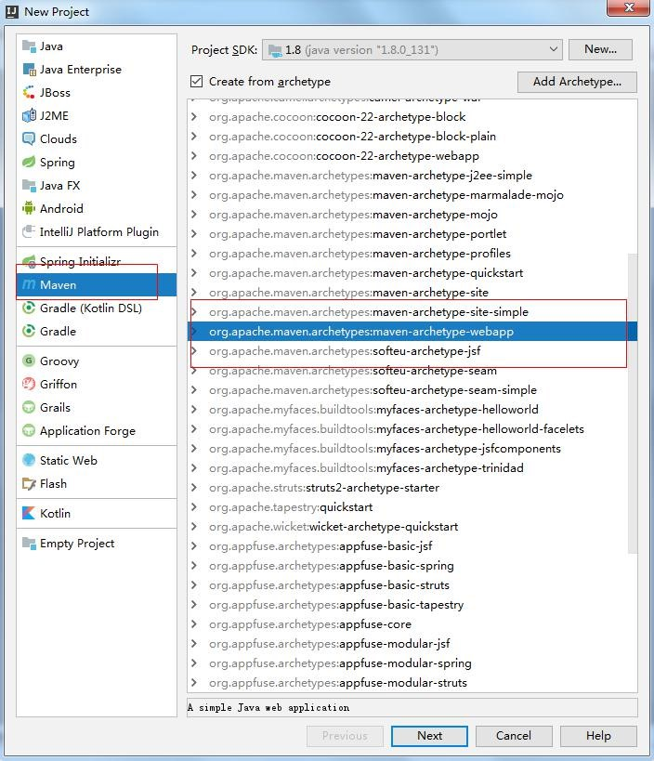

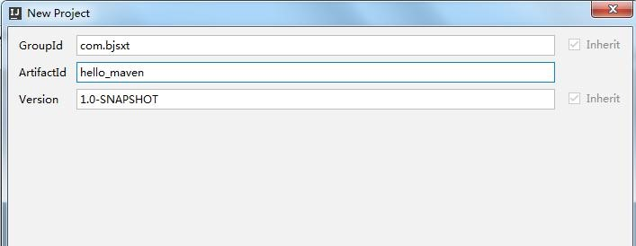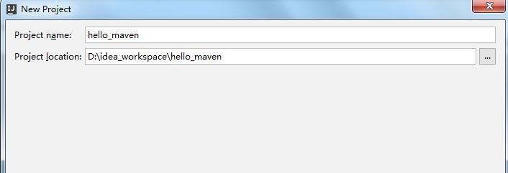

### 配置项目构建插件

-DarchetypeCatalog=internal

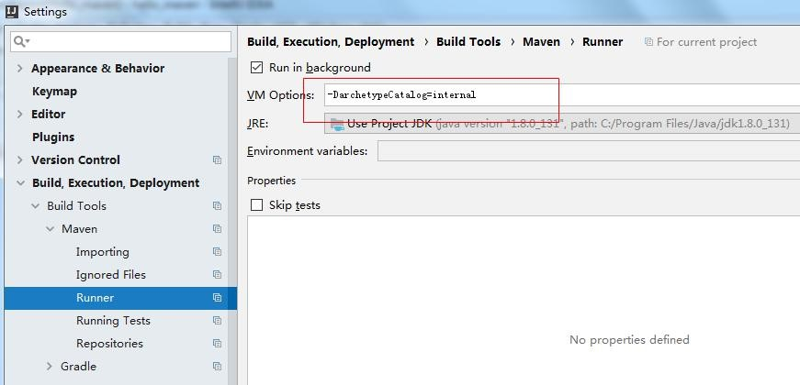

## 普通 Maven 项目开发过程

### 需求

将 jsp 中的表单数据提交到 servlet 中，并在控制台打印表单信息。

### 在项目中创建目录

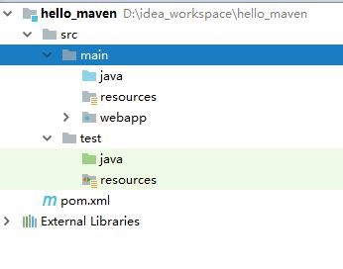

补充目录

### 修改目录类

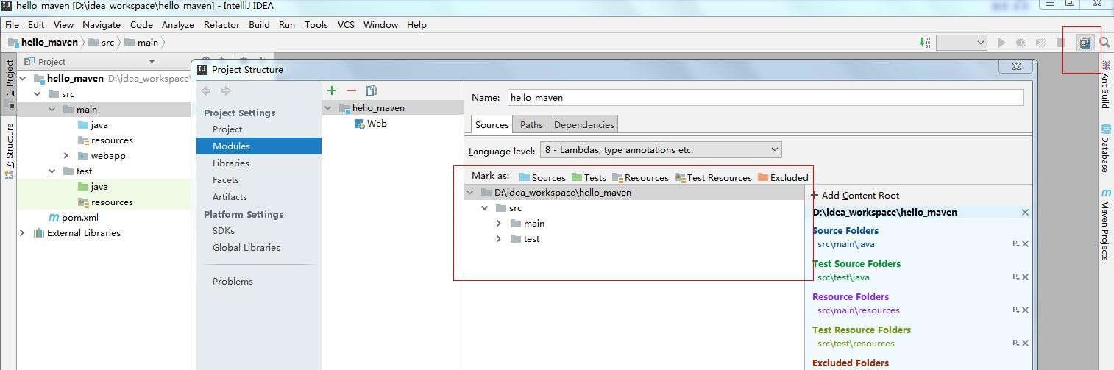

### 编写业务

#### 修改 pom 文件

*<?*xml version="1.0" encoding="UTF-8"*?>*

|  |  |  |  |  |  |  |  |  |  |  |  |  |  |  |  |  |  |  |  |  |  |  |  |  |  |  |  |  |  |  |  |  |  |  |  |  |  |  |  |  |  |  |  |  |  |  |  |  |  |  |  |  |  |  |  |  |  |  |  |  |  |  |  |  |  |  |  |  |  |  |  |  |  |  |  |  |  |  |  |  |  |  |  |  |  |  |  |  |  |  |  |  |  |  |  |  |  |  |  |  |  |  |  |  |  |  |  |  |  |  |  |  |  |  |  |  |  |  |  |  |  |  |  |  |  |  |  |  |  |  |  |  |  |  |  |  |  |  |  |
| --- | --- | --- | --- | --- | --- | --- | --- | --- | --- | --- | --- | --- | --- | --- | --- | --- | --- | --- | --- | --- | --- | --- | --- | --- | --- | --- | --- | --- | --- | --- | --- | --- | --- | --- | --- | --- | --- | --- | --- | --- | --- | --- | --- | --- | --- | --- | --- | --- | --- | --- | --- | --- | --- | --- | --- | --- | --- | --- | --- | --- | --- | --- | --- | --- | --- | --- | --- | --- | --- | --- | --- | --- | --- | --- | --- | --- | --- | --- | --- | --- | --- | --- | --- | --- | --- | --- | --- | --- | --- | --- | --- | --- | --- | --- | --- | --- | --- | --- | --- | --- | --- | --- | --- | --- | --- | --- | --- | --- | --- | --- | --- | --- | --- | --- | --- | --- | --- | --- | --- | --- | --- | --- | --- | --- | --- | --- | --- | --- | --- | --- | --- | --- | --- | --- | --- | --- | --- | --- | --- |
| |  | | --- | | <**project** | | **xmlns="http://maven.apache.org/POM/4.0.0"** | | | **xmlns:xsi="http://www.w3.org/2001/XMLSchema-in** | | |   **stance"**   |  |  |  |  |  |  |  |  |  |  |  |  |  |  |  |  |  |  |  |  | | --- | --- | --- | --- | --- | --- | --- | --- | --- | --- | --- | --- | --- | --- | --- | --- | --- | --- | --- | --- | | **xsi:schemaLocation="http://maven.apache.org/PO** | | | | | | | | | | | | | | | | | | | | | **M/4.0.0** | | | | **http://maven.apache.org/xsd/maven-4.0.0.xsd"**> | | | | | | | | | | | | | | | | | | | | <**modelVersion**> | | | | | | 4.0.0 | | </**modelVersion**> | | | | | | | | <**groupId**> | | | com.bjsxt | | | | </**groupId**> | | | | | | <**artifactId**> | | | | | hello_maven | | | | | </**artifactId**> | | | | | | | <**version**> | | | 1.0-SNAPSHOT | | | | | | </**version**> | | | | | | <**packaging**> | | | | war | | </**packaging**> | | | | | | <**name**> | hello_maven Maven Webapp | | | | | | | | | | | | </**name**> | | | |   *<!--* ***FIXME change it to the project's website***  *-->*   |  |  |  |  | | --- | --- | --- | --- | | <**url**> | http://www.example.com | | </**url**> | | <**dependencies**> | | |

|  |  |  |  |  |  |  |  |  |  |  |  |  |  |  |  |  |  |  |  |  |  |  |  |  |  |  |  |  |  |  |  |  |  |  |  |  |  |  |  |  |  |  |  |  |  |  |  |  |  |  |  |  |  |  |  |  |  |  |  |  |  |  |  |  |  |  |  |  |  |  |  |  |  |  |  |  |  |  |  |  |  |  |  |  |  |  |  |  |  |  |  |  |  |  |  |  |  |  |  |  |  |  |  |  |  |  |  |  |  |  |  |  |  |  |  |  |  |  |  |  |  |  |  |  |  |  |  |  |  |  |  |  |
| --- | --- | --- | --- | --- | --- | --- | --- | --- | --- | --- | --- | --- | --- | --- | --- | --- | --- | --- | --- | --- | --- | --- | --- | --- | --- | --- | --- | --- | --- | --- | --- | --- | --- | --- | --- | --- | --- | --- | --- | --- | --- | --- | --- | --- | --- | --- | --- | --- | --- | --- | --- | --- | --- | --- | --- | --- | --- | --- | --- | --- | --- | --- | --- | --- | --- | --- | --- | --- | --- | --- | --- | --- | --- | --- | --- | --- | --- | --- | --- | --- | --- | --- | --- | --- | --- | --- | --- | --- | --- | --- | --- | --- | --- | --- | --- | --- | --- | --- | --- | --- | --- | --- | --- | --- | --- | --- | --- | --- | --- | --- | --- | --- | --- | --- | --- | --- | --- | --- | --- | --- | --- | --- | --- | --- | --- | --- | --- | --- | --- | --- | --- | --- |
| |  |  |  |  | | --- | --- | --- | --- | | <**dependency**> | | | | | <**groupId**> | | junit | | | | | | </**groupId**> | | | | | <**artifactId**> | | | | | | junit | | | </**artifactId**> | | | | | <**version**> | | 4.11 | | | | | </**version**> | | | | | <**scope**> | test | | | </**scope**> | | | | | | | </**dependency**> | | | | | |   *<!--Servlet*坐标*-->*   |  |  |  |  |  |  | | --- | --- | --- | --- | --- | --- | | <**dependency**> | | | | | | | <**groupId**> | | | | javax.servlet | | | | | | </**groupId**> | | | <**artifactId**> | | | | | | | | servlet-api | | | </**artifactId**> | | | <**version**> | | | | 2.5 | | | | </**version**> | | | <**scope**> | | provided | | | | | | | </**scope**> | | | </**dependency**> | | | | | | | | </**dependencies**> | | | | | | | | | | <**build**> | | | | <**plugins**> | | | |   *<!--*配置*tomcat*插件*-->*   |  | | --- | | <**plugin**> | |
| |  |  |  | | --- | --- | --- | | **groupId** | >org.apache.tomcat.maven | </**groupId** |   < >   |  |  |  | | --- | --- | --- | | **artifactId** | >tomcat7-maven-plugin | </**artifactId** |   < >   |  | | --- | | **configuration** |   < >   |  |  |  | | --- | --- | --- | | **path** | >/ | </**path** |   < >   |  |  |  | | --- | --- | --- | | **port** | >9090 | </**port** |   < >   |  | | --- | | </**configuration** |   >   |  | | --- | | </**plugin** |   >   |  | | --- | | </**plugins** |  |  | | --- | | </**build** |   > >   |  | | --- | | </**project** |   > |

#### 创建 JSP

<

%@

**page**

**contentType**

=

"

**text/html;charset=UTF-8**

"

**language**

"

=

**java**

"

%>

<

**html**

>

<

**head**

>

<

**title**

>

Title

<

/

**title**

>

/

<

**head**

>

<

**body**

>

<

**form**

**action=**

**"addUser"**

**method=**

**"post"**

>

|  |  |  |  |  |  |  |
| --- | --- | --- | --- | --- | --- | --- |
| |  | | --- | | **input type="text"** |   用户名：<   |  | | --- | | **name="username"**/><**br**/> |  |  | | --- | | **input type="submit" value="OKOK"**/> |   <   |  | | --- | | </**form** |  |  | | --- | | </**body** |  |  | | --- | | </**html** |   > > > |

#### 创建 Servlet

|  |
| --- |
| **public class** AddUser **extends** HttpServlet {  @Override  **protectedvoid**doGet(HttpServletRequestreq,  HttpServletResponse resp) **throws**  ServletException, IOException { **this**.doGet(req, resp);  }  @Override  **protected void** doPost(HttpServletRequest  req, HttpServletResponse resp) **throws**  ServletException, IOException {  req.setCharacterEncoding(**"utf-8"**); |
| String username =  req.getParameter(**"username"**);  System.***out***.println(username);  } } |

#### 修改 web.xml

|  |  |
| --- | --- |
| **<!DOCTYPE web-app PUBLIC** | |
| <  < | **"-//SunMicrosystems,Inc.//DTDWebApplication** |
| **2.3//EN"**  **"http://java.sun.com/dtd/web-app_2_3.dtd" *>***   |  | | --- | | **web-app** |   >   |  | | --- | | **display-name** |   < >Archetype Created Web   |  | | --- | | </**display-name** |   Application >   |  | | --- | | **servlet** |   < >   |  |  |  | | --- | --- | --- | | **servlet-name** | >Servlet | </**servlet-name** |   < >   |  |  |  | | --- | --- | --- | | **servlet-class** | >com.bjsxt.web.AddUser | </**servlet-** |  |  | | --- | | **class** |   >   |  | | --- | | </**servlet** |   > |
| |  |  |  |  | | --- | --- | --- | --- | | <**servlet-mapping**> | | | | | <**servlet-name**> | | | Servlet | | </**servlet-name**> | | | <**url-pattern**> | | /addUser | | | </**url-pattern**> | | </**servlet-mapping**> | | | | | | </**web-app**> | | | |

## 启动 Maven 的 Tomcat 插件

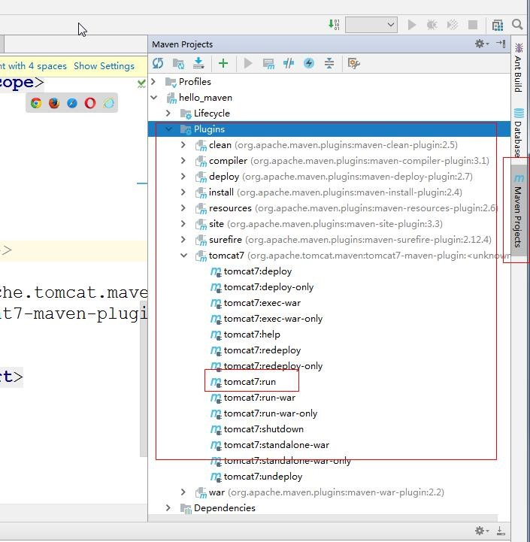

# 创建 Maven 的聚合工程

## 项目结构

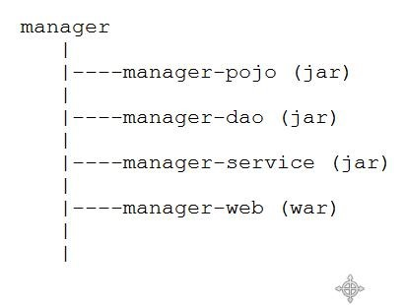

## 创建项目

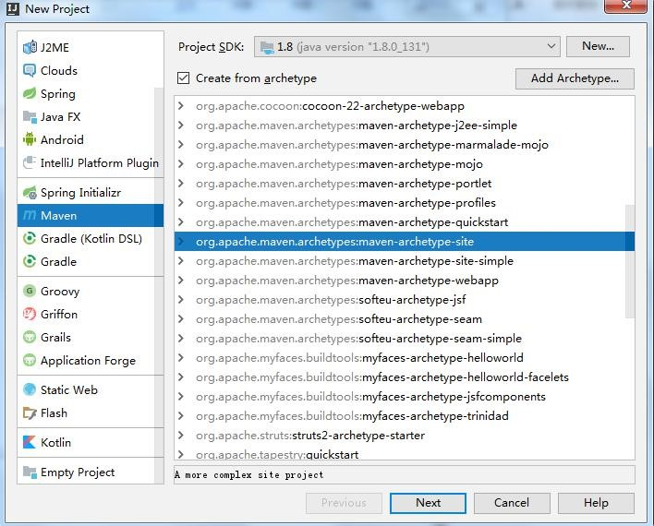

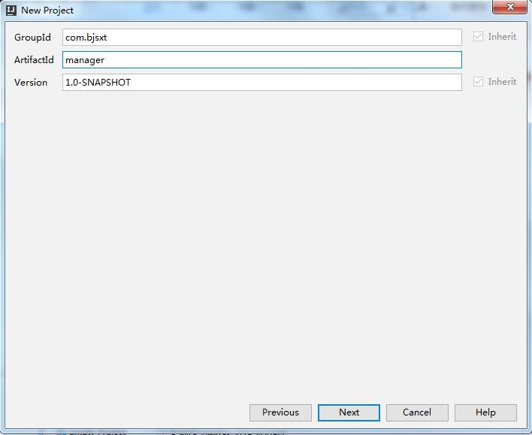

### 创建子模块

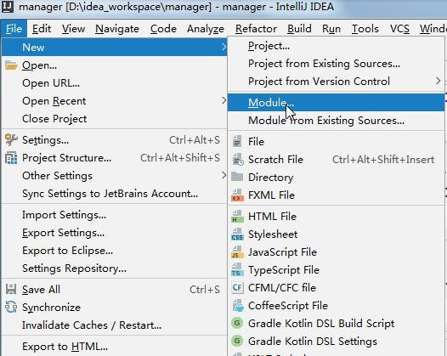

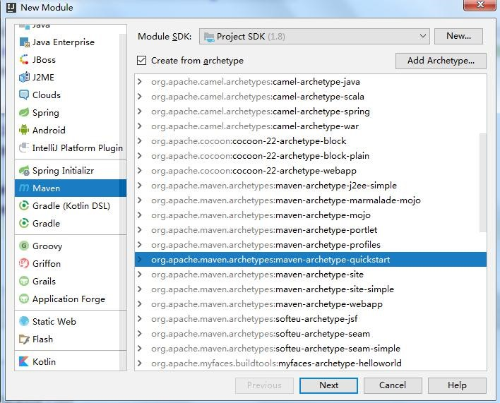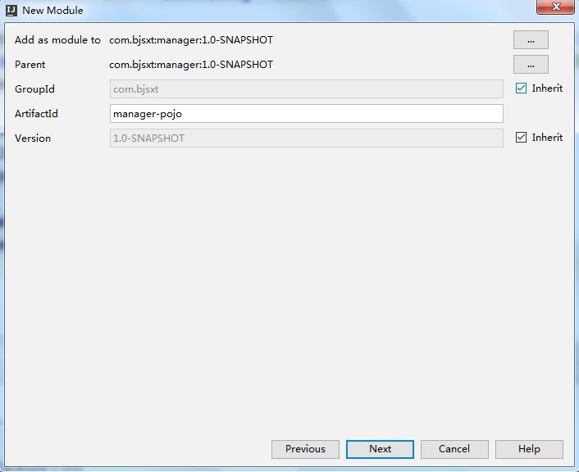

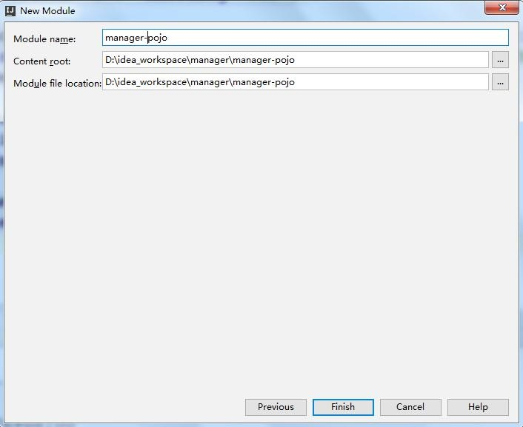

### 在父工程中添加依赖管理

|  |  |  |  |  |  |  |  |  |  |
| --- | --- | --- | --- | --- | --- | --- | --- | --- | --- |
| |  | | --- | | xml version="1.0" encoding="UTF-8" |   *<? ?>*   |  | | --- | | <project | | xmlns="http://maven.apache.org/POM/4.0.0" | | | xmlns:xsi="http://www.w3.org/2001/XMLSchema-in | |   stance"   |  |  | | --- | --- | | xsi:schemaLocation="http://maven.apache.org/PO | | | M/4.0.0 | |

http://maven.apache.org/xsd/maven-4.0.0.xsd">

|  |  |  |  |  |  |  |  |  |  |  |  |
| --- | --- | --- | --- | --- | --- | --- | --- | --- | --- | --- | --- |
| <modelVersion> | | | | 4.0.0 | | </modelVersion> | | | | | |
| <groupId> | com.bjsxt | | | | </groupId> | | | |
| <artifactId> | | | manager | | | </artifactId> | | | | |
| <packaging> | | pom | | </packaging> | | | |
| <version> | 1.0-SNAPSHOT | | | | | | </version> | | |

<modules>

|  |  |  |  |  |  |  |
| --- | --- | --- | --- | --- | --- | --- |
| <module> | manager-pojo | | </module> | | | |
| <module> | manager-mapper | | | </module> | | | |
| <module> | manager-service | | | | </module> | | | |
| <module> | manager-web | </module> | | | |

</modules>

|  |  |  |
| --- | --- | --- |
| <name> | Maven | </name> |

*<!--*对依赖的坐标的版本做集中管理*-->*

<properties>

|  |  |  |  |  |  |  |  |
| --- | --- | --- | --- | --- | --- | --- | --- |
| <junit.version> | | 4.12 | | </junit.version> | | | |
| <spring.version> | | 4.1.3.RELEASE | | | | | | </spring.version> | | |
| <mybatis.version> | | | 3.2.8 | | | </mybatis.version> | | |
| <mybatis.spring.version> | | | | | | 1.2.2 | | </mybatis.spring. | | |

version>

|  |  |  |  |  |  |  |  |  |  |  |  |
| --- | --- | --- | --- | --- | --- | --- | --- | --- | --- | --- | --- |
| <mysql.version> | | | 5.1.32 | | | | | </mysql.version> | | | |
| <druid.version> | | | 1.0.9 | | | | </druid.version> | | | |
| <jstl.version> | | 1.2 | | | </jstl.version> | | | | |
| <servlet.version> | | | | | 2.5 | | </servlet.version> | | | | | |
| <jsp.version> | 2.0 | | | </jsp.version> | | | | |
| <tomcat.version> | | | | 2.2 | | </tomcat.version> | | | | |

</properties>

<dependencyManagement>

<dependencies>

<dependency>

|  |  |  |  |  |
| --- | --- | --- | --- | --- |
| <groupId> | junit | | </groupId> | |
| <artifactId> | | junit | | </artifactId> | |

|  |  |  |
| --- | --- | --- |
| <version> | ${junit.version} | </version |

>

</dependency>

*<!--mybatis-->*

<dependency>

|  |  |  |  |  |  |
| --- | --- | --- | --- | --- | --- |
| <groupId> | org.mybatis | | | </groupId> | |
| <artifactId> | | mybatis | </artifactId> | | | |
| <version> | ${mybatis.version} | | | | </version> | | |

</dependency>

<dependency>

|  |  |  |  |  |  |  |
| --- | --- | --- | --- | --- | --- | --- |
| <groupId> | | | org.mybatis | | </groupId> | |
| <artifactId> | | | mybatis-spring | | </artifactId> | | | |
| <version> | | ${mybatis.spring.version} | | | | | </version> | | |

</dependency>

*<!--mql-->*

<dependency>

|  |  |  |  |  |
| --- | --- | --- | --- | --- |
| <groupId> | | mysql | </groupId> | |
| <artifactId> | | mysql-connector-java | | | </artifactId> | |

|  |  |  |
| --- | --- | --- |
| <version> | ${mysql.version} | </version |

>

</dependency>

<dependency>

|  |  |  |  |  |
| --- | --- | --- | --- | --- |
| <groupId> | com.alibaba | | | </groupId> |
| <artifactId> | | druid | </artifactId> | |

|  |  |  |
| --- | --- | --- |
| <**version**> | ${druid.version} | </**version** |

>

</**dependency**>

*<!--spring-->*

<**dependency**>

|  |  |  |  |  |  |  |  |
| --- | --- | --- | --- | --- | --- | --- | --- |
| <**groupId**> | | org.springframework | | | | </**groupId**> | |
| <**artifactId**> | | | spring-context | | </**artifactId**> | | | |
| <**version**> | | | ${spring.version} | | | </**version**> | | |

</**dependency**>

<**dependency**>

|  |  |  |  |  |  |  |  |
| --- | --- | --- | --- | --- | --- | --- | --- |
| <**groupId**> | | org.springframework | | | </**groupId**> | | |
| <**artifactId**> | | | spring-beans | | </**artifactId**> | | | |
| <**version**> | | ${spring.version} | | | | </**version**> | |

</**dependency**>

<**dependency**>

|  |  |  |  |  |  |  |  |
| --- | --- | --- | --- | --- | --- | --- | --- |
| <**groupId**> | | org.springframework | | | </**groupId**> | | |
| <**artifactId**> | | | spring-jdbc | | </**artifactId**> | | |
| <**version**> | | ${spring.version} | | | | </**version**> | |

</**dependency**>

<**dependency**>

|  |  |  |  |  |  |  |  |
| --- | --- | --- | --- | --- | --- | --- | --- |
| <**groupId**> | | org.springframework | | | | </**groupId**> | |
| <**artifactId**> | | | spring-webmvc | | </**artifactId**> | | |
| <**version**> | | | ${spring.version} | | | </**version**> | |

</**dependency**>

<**dependency**>

|  |  |  |  |  |  |  |  |
| --- | --- | --- | --- | --- | --- | --- | --- |
| <**groupId**> | | org.springframework | | | | </**groupId**> | |
| <**artifactId**> | | | spring-aspects | | </**artifactId**> | | | |
| <**version**> | | | ${spring.version} | | | </**version**> | | |

</**dependency**>

*<!--jsp&servlet-->*

<**dependency**>

|  |  |  |  |  |
| --- | --- | --- | --- | --- |
| <**groupId**> | jstl | | </**groupId**> | |
| <**artifactId**> | | jstl | | </**artifactId**> | | |
| <**version**> | ${jstl.version} | | | | | </**version**> | |

</**dependency**>

<**dependency**>

|  |  |  |  |  |  |  |
| --- | --- | --- | --- | --- | --- | --- |
| <**groupId**> | | javax.servlet | | </**groupId**> | | |
| <**artifactId**> | | | servlet-api | | | </**artifactId**> | | |
| <**version**> | | ${servlet-api.version} | | | | </**version**> | | |

</**dependency**>

<**dependency**>

|  |  |  |  |  |  |
| --- | --- | --- | --- | --- | --- |
| <**groupId**> | javax.servlet | | | </**groupId**> | |
| <**artifactId**> | | jsp-api | </**artifactId**> | | |
| <**version**> | ${jsp.version} | | | | </**version**> | |

</**dependency**>

</**dependencies**>

</**dependencyManagement**>

<**build**>

*<!--*配置资源拷贝插件*-->*

<**resources**>

<**resource**>

|  |  |  |
| --- | --- | --- |
| <**directory**> | src/main/java | </**directory**> |

<**includes**>

|  |  |  |
| --- | --- | --- |
| <**include**> | **/*.xml | </**include**> |

</**includes**>

</**resource**>

<**resource**>

|  |  |  |
| --- | --- | --- |
| <**directory**> | src/main/resources | </**directory**> |

<**includes**>

|  |  |  |  |
| --- | --- | --- | --- |
| <**include**> | **/*.xml | </**include**> | |
| <**include**> | **/*.properties | | </**include**> | |

</**includes**>

|  |  |  |  |  |  |  |  |  |  |  |  |  |  |  |  |  |  |  |  |  |  |  |  |  |  |  |  |  |  |  |  |  |  |  |  |  |  |  |  |  |  |  |  |  |  |  |  |  |  |  |  |  |  |  |  |  |  |  |  |  |  |  |  |  |  |  |  |  |  |  |  |  |  |  |  |  |  |  |  |  |  |  |  |  |  |  |  |  |  |  |  |  |  |  |  |  |  |  |  |  |  |  |  |  |  |  |  |  |  |  |  |  |  |  |  |  |  |  |  |  |  |  |  |  |  |  |  |  |  |  |  |  |
| --- | --- | --- | --- | --- | --- | --- | --- | --- | --- | --- | --- | --- | --- | --- | --- | --- | --- | --- | --- | --- | --- | --- | --- | --- | --- | --- | --- | --- | --- | --- | --- | --- | --- | --- | --- | --- | --- | --- | --- | --- | --- | --- | --- | --- | --- | --- | --- | --- | --- | --- | --- | --- | --- | --- | --- | --- | --- | --- | --- | --- | --- | --- | --- | --- | --- | --- | --- | --- | --- | --- | --- | --- | --- | --- | --- | --- | --- | --- | --- | --- | --- | --- | --- | --- | --- | --- | --- | --- | --- | --- | --- | --- | --- | --- | --- | --- | --- | --- | --- | --- | --- | --- | --- | --- | --- | --- | --- | --- | --- | --- | --- | --- | --- | --- | --- | --- | --- | --- | --- | --- | --- | --- | --- | --- | --- | --- | --- | --- | --- | --- | --- | --- |
| |  |  | | --- | --- | | </**resource**> | | | </**resources**> | |   *<!--*配置*tomcat*插件*-->*   |  |  |  |  |  |  |  |  |  |  |  |  |  | | --- | --- | --- | --- | --- | --- | --- | --- | --- | --- | --- | --- | --- | | <**pluginManagement**> | | | | | | | | | | | | | | <**plugins**> | | | | | | | | <**plugin**> | | | | | | | | <**groupId**> | | | | | | org.apache.tomcat.maven | | | | | | | | | | | </**groupId**> | | | <**artifactId**> | | | | | | | | | tomcat7-maven-plugin | | | | | | | | </**artifactId**> | | | | | <**version**> | | | | | | | | | ${tomcat.version} | | | | </**version**> | | | </**plugin**> | | | | | | | | | | </**plugins**> | | | | | | | | | | </**pluginManagement**> | | | | | | | | | | | | | | | </**build**> | | | | | | | </**project**> | | | | | | | | |

### 配置子模块的依赖注入

**5.1Manager-mapper**

|  |  |
| --- | --- |
| |  | | --- | | **xml version="1.0" encoding="UTF-8"** |   *<? ?>* |

|  |  |  |  |  |  |  |  |  |  |  |  |  |  |  |  |  |  |  |  |  |  |  |  |  |  |  |  |  |  |  |  |  |  |  |  |  |  |  |  |  |  |  |  |  |  |  |  |  |  |  |  |  |  |  |  |  |  |  |  |  |  |  |  |  |  |  |  |  |  |  |  |  |  |  |  |  |  |  |  |  |  |  |  |  |  |  |  |  |  |  |  |  |  |  |  |  |  |  |  |  |  |  |  |  |  |  |  |  |  |  |  |  |  |  |  |  |  |  |  |  |  |  |  |  |  |  |  |  |  |  |  |  |  |  |  |  |  |  |  |  |  |  |  |  |  |  |  |  |  |  |  |  |  |  |  |  |  |  |  |  |  |  |  |  |  |  |  |  |  |  |  |  |  |  |  |  |  |  |  |  |  |  |  |  |  |  |  |  |  |  |  |  |  |  |  |  |  |  |  |  |  |  |  |  |  |  |  |  |  |  |  |  |  |  |  |  |  |  |  |  |  |  |  |  |  |  |  |  |  |  |  |  |  |  |  |  |  |  |  |  |  |  |  |  |  |
| --- | --- | --- | --- | --- | --- | --- | --- | --- | --- | --- | --- | --- | --- | --- | --- | --- | --- | --- | --- | --- | --- | --- | --- | --- | --- | --- | --- | --- | --- | --- | --- | --- | --- | --- | --- | --- | --- | --- | --- | --- | --- | --- | --- | --- | --- | --- | --- | --- | --- | --- | --- | --- | --- | --- | --- | --- | --- | --- | --- | --- | --- | --- | --- | --- | --- | --- | --- | --- | --- | --- | --- | --- | --- | --- | --- | --- | --- | --- | --- | --- | --- | --- | --- | --- | --- | --- | --- | --- | --- | --- | --- | --- | --- | --- | --- | --- | --- | --- | --- | --- | --- | --- | --- | --- | --- | --- | --- | --- | --- | --- | --- | --- | --- | --- | --- | --- | --- | --- | --- | --- | --- | --- | --- | --- | --- | --- | --- | --- | --- | --- | --- | --- | --- | --- | --- | --- | --- | --- | --- | --- | --- | --- | --- | --- | --- | --- | --- | --- | --- | --- | --- | --- | --- | --- | --- | --- | --- | --- | --- | --- | --- | --- | --- | --- | --- | --- | --- | --- | --- | --- | --- | --- | --- | --- | --- | --- | --- | --- | --- | --- | --- | --- | --- | --- | --- | --- | --- | --- | --- | --- | --- | --- | --- | --- | --- | --- | --- | --- | --- | --- | --- | --- | --- | --- | --- | --- | --- | --- | --- | --- | --- | --- | --- | --- | --- | --- | --- | --- | --- | --- | --- | --- | --- | --- | --- | --- | --- | --- | --- | --- | --- | --- | --- | --- | --- | --- | --- | --- | --- | --- | --- | --- | --- | --- | --- |
| |  | | --- | | <**project** | | **xmlns="http://maven.apache.org/POM/4.0.0"** | | | **xmlns:xsi="http://www.w3.org/2001/XMLSchema-in** | | |   **stance"**   |  |  |  |  |  |  |  |  |  |  |  |  |  |  |  |  |  |  |  |  |  |  |  |  |  |  |  |  | | --- | --- | --- | --- | --- | --- | --- | --- | --- | --- | --- | --- | --- | --- | --- | --- | --- | --- | --- | --- | --- | --- | --- | --- | --- | --- | --- | --- | | **xsi:schemaLocation="http://maven.apache.org/PO** | | | | | | | | | | | | | | | | | | | | | | | | | | | | | **M/4.0.0** | | | | **http://maven.apache.org/xsd/maven-4.0.0.xsd"**> | | | | | | | | | | | | | | | | | | | | | | | | | | | | <**parent**> | | | | | <**artifactId**> | | | | | | | | | manager | | | | | </**artifactId**> | | | | | | | | | | <**groupId**> | | | | | | | com.bjsxt | | | | | | </**groupId**> | | | | | | <**version**> | | | | | | | 1.0-SNAPSHOT | | | | | | | | </**version**> | | | | | | | </**parent**> | | | | | | | <**modelVersion**> | | | | | | | | | 4.0.0 | | | </**modelVersion**> | | | | | | | | | | <**artifactId**> | | | | | | | manager-mapper | | | | | | | | | | | </**artifactId**> | | | | | | | | <**dependencies**> | | | | | | | | | | <**dependency**> | | | | | | | | | | <**groupId**> | | | | | | | | com.bjsxt | | | | | | </**groupId**> | | | | | | | <**artifactId**> | | | | | | manager-pojo | | | | | | | | </**artifactId**> | | | | | | | | | | | |
| <**version**> | 1.0-SNAPSHOT | </**version**> |

</**dependency**>

*<!--mybatis-->*

<**dependency**>

|  |  |  |  |  |
| --- | --- | --- | --- | --- |
| <**groupId**> | org.mybatis | | | </**groupId**> |
| <**artifactId**> | | mybatis | </**artifactId**> | | |

</**dependency**>

<**dependency**>

|  |  |  |  |  |  |
| --- | --- | --- | --- | --- | --- |
| <**groupId**> | | org.mybatis | | </**groupId**> | |
| <**artifactId**> | | mybatis-spring | | </**artifactId**> | |

</**dependency**>

*<!--mysql-->*

<**dependency**>

|  |  |  |  |  |
| --- | --- | --- | --- | --- |
| <**groupId**> | | mysql | </**groupId**> | |
| <**artifactId**> | | mysql-connector-java | | | </**artifactId**> | |

</**dependency**>

<**dependency**>

|  |  |  |  |  |
| --- | --- | --- | --- | --- |
| <**groupId**> | com.alibaba | | | </**groupId**> |
| <**artifactId**> | | druid | </**artifactId**> | |

</**dependency**>

|  |  |  |
| --- | --- | --- |
| |  | | --- | | </**dependencies** |   >   |  | | --- | | </**project** |   > |

**5.2Manager-service**

|  |  |  |  |  |  |  |  |  |  |  |  |  |  |  |  |  |  |  |  |  |  |  |  |  |  |  |  |
| --- | --- | --- | --- | --- | --- | --- | --- | --- | --- | --- | --- | --- | --- | --- | --- | --- | --- | --- | --- | --- | --- | --- | --- | --- | --- | --- | --- |
| |  | | --- | | **xml version="1.0" encoding="UTF-8"** |   *<? ?>*   |  | | --- | | **project** |   <   |  | | --- | | **xmlns="http://maven.apache.org/POM/4.0.0"** | | **xmlns:xsi="http://www.w3.org/2001/XMLSchema-in** | |   **stance"**   |  |  | | --- | --- | | **xsi:schemaLocation="http://maven.apache.org/PO** | | | **M/4.0.0** |  |  | | --- | | **http://maven.apache.org/xsd/maven-4.0.0.xsd"** |   >   |  | | --- | | **parent** |   < >   |  |  |  | | --- | --- | --- | | **artifactId** | >manager | </**artifactId** |   < >   |  |  |  | | --- | --- | --- | | **groupId** | >com.bjsxt | </**groupId** |   < >   |  |  |  | | --- | --- | --- | | **version** | >1.0-SNAPSHOT | </**version** |   < >   |  | | --- | | </**parent** |   >   |  |  |  | | --- | --- | --- | | **modelVersion** | >4.0.0 | </**modelVersion** |   < > | | | | |
| <**artifactId**> | manager-service | </**artifactId**> |

<**dependencies**>

<**dependency**>

|  |  |  |  |  |  |
| --- | --- | --- | --- | --- | --- |
| <**groupId**> | | com.bjsxt | | </**groupId**> | |
| <**artifactId**> | | manager-mapper | | </**artifactId**> | | | |
| <**version**> | | 1.0-SNAPSHOT | | | </**version**> | | |

</**dependency**>

*<!--spring-->*

<**dependency**>

|  |  |  |  |  |
| --- | --- | --- | --- | --- |
| <**groupId**> | org.springframework | | | </**groupId**> |
| <**artifactId**> | | spring-context | </**artifactId**> | | |

</**dependency**>

<**dependency**>

|  |  |  |  |  |  |
| --- | --- | --- | --- | --- | --- |
| <**groupId**> | org.springframework | | | </**groupId**> | |
| <**artifactId**> | | spring-beans | </**artifactId**> | |

</**dependency**>

<**dependency**>

|  |  |  |  |  |  |  |  |  |  |  |  |  |  |  |  |  |  |
| --- | --- | --- | --- | --- | --- | --- | --- | --- | --- | --- | --- | --- | --- | --- | --- | --- | --- |
| |  |  |  | | --- | --- | --- | | **groupId** | >org.springframework | </**groupId** |   < >   |  |  |  | | --- | --- | --- | | **artifactId** | >spring-jdbc | </**artifactId** |   < >   |  | | --- | | </**dependency** |   >   |  | | --- | | **dependency** |   < >   |  |  |  | | --- | --- | --- | | **groupId** | >org.springframework | </**groupId** |   < >   |  |  |  | | --- | --- | --- | | **artifactId** | >spring-aspects | </**artifactId** |   < >   |  | | --- | | </**dependency** |   >   |  | | --- | | </**dependencies** |   >   |  | | --- | | </**project** |   > |

**5.3Manager-web**

|  |  |  |  |  |  |
| --- | --- | --- | --- | --- | --- |
| |  | | --- | | **xml version="1.0" encoding="UTF-8"** |   *<? ?>*   |  | | --- | | **project** |   <   |  | | --- | | **xmlns="http://maven.apache.org/POM/4.0.0"** | | **xmlns:xsi="http://www.w3.org/2001/XMLSchema-in** | |   **stance"** |

**xsi:schemaLocation="http://maven.apache.org/PO**

**M/4.0.0**

**http://maven.apache.org/xsd/maven-4.0.0.xsd"**>

<**parent**>

|  |  |  |  |  |  |  |  |
| --- | --- | --- | --- | --- | --- | --- | --- |
| <**artifactId**> | | manager | | </**artifactId**> | | | |
| <**groupId**> | com.bjsxt | | </**groupId**> | | |
| <**version**> | 1.0-SNAPSHOT | | | | </**version**> | |

</**parent**>

|  |  |  |  |  |  |  |
| --- | --- | --- | --- | --- | --- | --- |
| <**modelVersion**> | | | 4.0.0 | </**modelVersion**> | | |
| <**artifactId**> | | manager-web | | | </**artifactId**> | | |
| <**packaging**> | war | | </**packaging**> | | |

<**dependencies**>

<**dependency**>

|  |  |  |  |  |  |
| --- | --- | --- | --- | --- | --- |
| <**groupId**> | | com.bjsxt | | </**groupId**> | |
| <**artifactId**> | | manager-service | | </**artifactId**> | | | |
| <**version**> | | 1.0-SNAPSHOT | | | </**version**> | | |

</**dependency**>

<**dependency**>

|  |  |  |
| --- | --- | --- |
| <**groupId**> | org.springframework | </**groupId**> |

|  |  |  |  |  |  |  |  |  |  |  |  |  |  |  |  |  |  |  |  |  |  |  |  |  |  |  |  |  |  |  |  |  |  |  |  |  |  |  |  |  |  |  |  |  |  |  |  |  |  |  |  |  |  |  |  |  |  |  |  |  |  |  |  |  |  |  |  |  |  |  |  |  |  |  |  |  |  |  |  |  |  |  |  |  |  |  |  |  |  |  |  |  |  |  |  |  |  |  |  |  |  |  |  |  |  |  |  |  |  |  |  |  |  |  |  |  |  |  |  |  |  |  |  |  |  |  |  |  |  |  |  |  |  |  |  |  |  |  |  |  |  |  |  |  |  |  |  |  |  |  |  |  |  |  |  |  |  |  |  |  |  |  |  |  |  |  |  |  |  |  |  |  |  |  |  |  |  |  |  |  |  |  |  |  |  |  |  |  |  |  |  |  |  |  |  |  |  |
| --- | --- | --- | --- | --- | --- | --- | --- | --- | --- | --- | --- | --- | --- | --- | --- | --- | --- | --- | --- | --- | --- | --- | --- | --- | --- | --- | --- | --- | --- | --- | --- | --- | --- | --- | --- | --- | --- | --- | --- | --- | --- | --- | --- | --- | --- | --- | --- | --- | --- | --- | --- | --- | --- | --- | --- | --- | --- | --- | --- | --- | --- | --- | --- | --- | --- | --- | --- | --- | --- | --- | --- | --- | --- | --- | --- | --- | --- | --- | --- | --- | --- | --- | --- | --- | --- | --- | --- | --- | --- | --- | --- | --- | --- | --- | --- | --- | --- | --- | --- | --- | --- | --- | --- | --- | --- | --- | --- | --- | --- | --- | --- | --- | --- | --- | --- | --- | --- | --- | --- | --- | --- | --- | --- | --- | --- | --- | --- | --- | --- | --- | --- | --- | --- | --- | --- | --- | --- | --- | --- | --- | --- | --- | --- | --- | --- | --- | --- | --- | --- | --- | --- | --- | --- | --- | --- | --- | --- | --- | --- | --- | --- | --- | --- | --- | --- | --- | --- | --- | --- | --- | --- | --- | --- | --- | --- | --- | --- | --- | --- | --- | --- | --- | --- | --- | --- | --- | --- | --- | --- | --- | --- | --- | --- | --- | --- | --- | --- |
| |  |  |  |  |  | | --- | --- | --- | --- | --- | | <**artifactId**> | | spring-webmvc | | </**artifactId**> | | </**dependency**> | |   *<!--jsp&servlet-->*   |  |  |  |  |  |  | | --- | --- | --- | --- | --- | --- | | <**dependency**> | | | | | | | <**groupId**> | | | | | | jstl | | | </**groupId**> | | | | | | <**artifactId**> | | | | | | | | jstl | | | </**artifactId**> | | | | | <**scope**> | | | provided | | | | | | | </**scope**> | | | | | </**dependency**> | | | | | | | | | <**dependency**> | | | | | | | <**groupId**> | | | | | | javax.servlet | | | | | | | </**groupId**> | | | | <**artifactId**> | | | | | | | | servlet-api | | | | | | </**artifactId**> | | | | <**scope**> | | | provided | | | | | | | </**scope**> | | | | | </**dependency**> | | | | | | | | | <**dependency**> | | | | | | | <**groupId**> | | | | | | javax.servlet | | | | | | | </**groupId**> | | | | <**artifactId**> | | | | | | | | jsp-api | | | | </**artifactId**> | | | | | <**scope**> | | | provided | | | | | | | </**scope**> | | | | | </**dependency**> | | | | | | | | | </**dependencies**> | | | | | | | <**build**> | | | | <**plugins**> | | | |

|  |  |  |  |  |  |  |  |  |  |  |  |  |  |  |  |  |  |  |  |  |  |  |  |  |  |  |  |  |  |  |  |  |  |  |  |  |  |  |  |  |  |  |  |  |  |  |  |  |  |  |  |  |  |  |  |  |  |  |  |  |  |  |  |  |  |  |  |  |  |  |  |  |  |  |  |  |  |  |  |  |  |  |  |  |  |  |  |  |  |  |  |  |  |  |  |  |  |  |  |  |  |  |  |  |  |  |  |  |  |  |  |  |  |  |  |  |  |  |  |  |  |  |  |  |  |  |  |  |  |  |  |  |  |  |  |  |  |  |  |  |  |  |  |  |  |  |  |  |  |  |  |  |  |  |  |  |  |  |  |  |  |  |  |  |  |  |  |  |  |  |  |  |  |  |  |  |  |  |  |  |  |  |  |  |  |  |  |  |  |  |  |  |  |  |  |  |  |  |  |  |  |  |
| --- | --- | --- | --- | --- | --- | --- | --- | --- | --- | --- | --- | --- | --- | --- | --- | --- | --- | --- | --- | --- | --- | --- | --- | --- | --- | --- | --- | --- | --- | --- | --- | --- | --- | --- | --- | --- | --- | --- | --- | --- | --- | --- | --- | --- | --- | --- | --- | --- | --- | --- | --- | --- | --- | --- | --- | --- | --- | --- | --- | --- | --- | --- | --- | --- | --- | --- | --- | --- | --- | --- | --- | --- | --- | --- | --- | --- | --- | --- | --- | --- | --- | --- | --- | --- | --- | --- | --- | --- | --- | --- | --- | --- | --- | --- | --- | --- | --- | --- | --- | --- | --- | --- | --- | --- | --- | --- | --- | --- | --- | --- | --- | --- | --- | --- | --- | --- | --- | --- | --- | --- | --- | --- | --- | --- | --- | --- | --- | --- | --- | --- | --- | --- | --- | --- | --- | --- | --- | --- | --- | --- | --- | --- | --- | --- | --- | --- | --- | --- | --- | --- | --- | --- | --- | --- | --- | --- | --- | --- | --- | --- | --- | --- | --- | --- | --- | --- | --- | --- | --- | --- | --- | --- | --- | --- | --- | --- | --- | --- | --- | --- | --- | --- | --- | --- | --- | --- | --- | --- | --- | --- | --- | --- | --- | --- | --- | --- | --- | --- | --- | --- | --- | --- |
| |  |  |  |  |  |  | | --- | --- | --- | --- | --- | --- | | <**plugin**> | | | | | | | <**groupId**> | | | | org.apache.tomcat.maven | | | | | | | | | | | | | | | | | | | | </**groupId**> | | | | | | <**artifactId**> | | | | | | | tomcat7-maven-plugin | | | | | | | | | | | | | | | | | </**artifactId**> | | | | | | | <**configuration**> | | | | | | | | | | | <**path**> | | | | / | </**path**> | | | | | | | <**port**> | | | | 9090 | | | </**port**> | | | | | | | </**configuration**> | | | | | | | | | | | | | </**plugin**> | | | | | | | | | </**plugins**> | | | | | | | | | | | </**build**> | | | | | | </**project**> | | | | | | <**dependency**> | | | | | | | | | <**groupId**> | | | | | | | junit | | | | | </**groupId**> | | | | | | | | <**artifactId**> | | | | | | | | | | junit | | | | | </**artifactId**> | | | | | | | | | | | </**dependency**> | | | | | | | | | | | |

## 创建表

CREATE TABLE `users` (

`userid` int(11) NOT NULL AUTO_INCREMENT,

`username` varchar(30) DEFAULT NULL,

`userage` int(11) DEFAULT NULL,

PRIMARY KEY (`userid`)

) ENGINE=InnoDB AUTO_INCREMENT=2 DEFAULT CHARSET=utf8;

## 添加 pojo 与 mapper

### 创建 Pojo

|  |
| --- |
| **public class** Users { **private** Integer **userid**; **private** String **username**; **private** Integer **userage**;  **public** Integer getUserid() { **return userid**;  }  **public void** setUserid(Integer userid) { **this**.**userid** = userid;  }  **public** String getUsername() { **return username**;  }  **public void** setUsername(String username) { |
| **this**.**username** = username;  }  **public** Integer getUserage() { **return userage**;  }  **public void** setUserage(Integer userage) { **this**.**userage** = userage;  } } |

### 创建 Mapper 接口与映射配置文件

|  |  |
| --- | --- |
| **public interface** UsersMapper { **void** insertUser(Users users); List<Users> selectUserAll();  } | |
| |  | | --- | | **xml version="1.0" encoding="UTF-8"** |   *<? ?>* | |
| **<!DOCTYPE mapper PUBLIC**   |  | | --- | | **Mapper 3.0//EN"** | | **"-//mybatis.org//DTD** |
|  |

|  |  |  |  |  |  |  |  |  |  |  |
| --- | --- | --- | --- | --- | --- | --- | --- | --- | --- | --- |
| |  | | --- | | **"http://mybatis.org/dtd/mybatis-3-mapper.dt** |   **d" *>***   |  | | --- | | **mapper** |   <   |  | | --- | | **namespace="com.bjsxt.mapper.UsersMapper"** |   >   |  | | --- | | **insert id="insertUser"** |   <   |  | | --- | | **parameterType="com.bjsxt.pojo.Users"** |   >  insert into users(username,userage)  values(#{username},#{userage})   |  | | --- | | </**insert** |   >   |  | | --- | | **select id="selectUserAll"** |  |  | | --- | | **resultType="com.bjsxt.pojo.Users"** |   < >  select *\** from users   |  | | --- | | </**select** |   >   |  | | --- | | </**mapper** |   > |

## 框架整合与测试

### 添加目录并设置目录标记

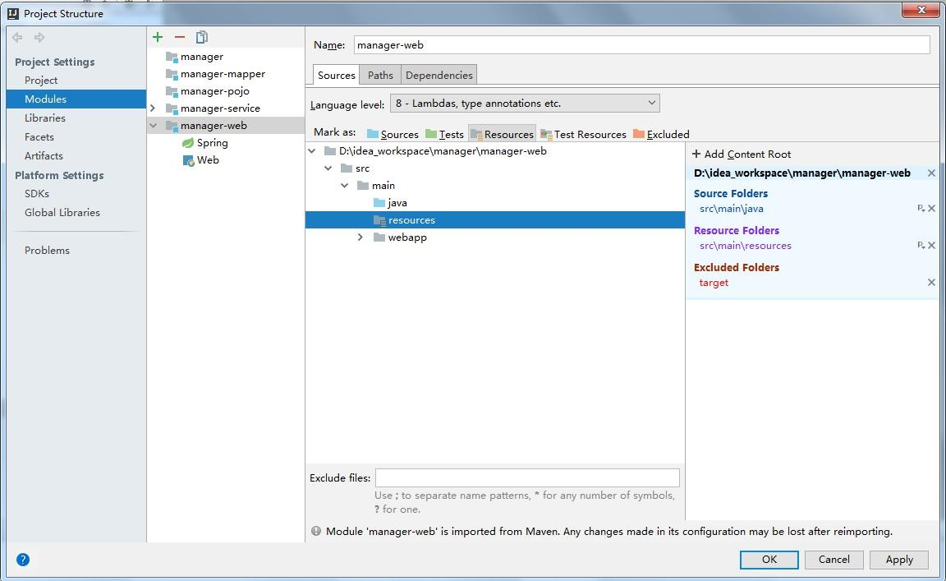

### 测试 mapper

|  |
| --- |
| @RunWith(SpringJUnit4ClassRunner.**class**) @ContextConfiguration(**"classpath:spring/applic ationContext-dao.xml"**) **public class** ManagerTest {  @Autowired  **private** UsersMapper **usersMapper**;  @Test |
| **public void** insertUserTest(){ Users users = **new** Users(); users.setUserage(20); users.setUsername(**"admin"**); **this**.**usersMapper**.insertUser(users);  } } |

### 整合SpringMVC

#### 配置 web.xml

|  |  |  |  |  |  |  |  |
| --- | --- | --- | --- | --- | --- | --- | --- |
| |  | | --- | | **xml version="1.0" encoding="UTF-8"** |   *<? ?>*   |  | | --- | | **web-app** |   <   |  | | --- | | **xmlns="http://java.sun.com/xml/ns/javaee"** |  |  | | --- | | **xmlns:xsi="http://www.w3.org/2001/XMLSchema-in** |   **stance"**   |  |  | | --- | --- | | **xsi:schemaLocation="http://java.sun.com/xml/ns** | | | **/javaee** |   **http://java.sun.com/xml/ns/javaee/web-app_2_5.**  **xsd"** |

|  |  |  |  |  |  |  |  |  |  |  |  |  |  |  |  |  |  |  |  |  |  |  |  |  |  |
| --- | --- | --- | --- | --- | --- | --- | --- | --- | --- | --- | --- | --- | --- | --- | --- | --- | --- | --- | --- | --- | --- | --- | --- | --- | --- |
| |  | | --- | | **version="2.5"**> |   *<!--* 上下文参数*,*告诉*Spring*配置文件路径*-->*   |  |  | | --- | --- | | <**context-param**> | | | <**param-name**> | | contextConfigLocation | | </**param-name**> |  |  | | --- | | <**param-value**> |   classpath:spring/applicationConte   |  | | --- | | </**param-value**> |   xt-*.xml   |  |  | | --- | --- | | </**context-param**> | | | <**listener**> |  |  | | --- | | <**listener-class**> |   org.springframework.web.contex   |  | | --- | | </**listener-class**> |   t.ContextLoaderListener   |  | | --- | | </**listener**> |   *<!--* 配置*springmvc -->*   |  |  | | --- | --- | | <**servlet**> | | | <**servlet-name**> | | springmvc | </**servlet-name**> |  |  | | --- | | <**servlet-class**> |   org.springframework.web.servlet   |  | | --- | | </**servlet-class**> |   .DispatcherServlet   |  | | --- | | <**init-param**> | |

|  |  |  |  |  |  |  |  |  |  |  |  |  |  |  |  |  |  |  |  |  |  |  |  |  |  |  |  |  |  |  |  |  |  |  |  |  |  |  |  |  |  |  |  |  |  |  |  |  |  |  |  |  |  |  |  |  |  |  |  |  |  |  |  |  |  |  |  |  |  |  |  |  |  |  |  |  |  |  |  |  |  |  |  |  |  |  |  |  |  |  |  |  |  |  |  |  |  |  |  |  |  |  |  |  |  |  |  |  |  |  |  |  |  |  |  |  |  |  |  |  |  |  |  |  |  |  |  |  |  |  |  |  |  |  |  |  |  |  |  |  |  |  |  |  |
| --- | --- | --- | --- | --- | --- | --- | --- | --- | --- | --- | --- | --- | --- | --- | --- | --- | --- | --- | --- | --- | --- | --- | --- | --- | --- | --- | --- | --- | --- | --- | --- | --- | --- | --- | --- | --- | --- | --- | --- | --- | --- | --- | --- | --- | --- | --- | --- | --- | --- | --- | --- | --- | --- | --- | --- | --- | --- | --- | --- | --- | --- | --- | --- | --- | --- | --- | --- | --- | --- | --- | --- | --- | --- | --- | --- | --- | --- | --- | --- | --- | --- | --- | --- | --- | --- | --- | --- | --- | --- | --- | --- | --- | --- | --- | --- | --- | --- | --- | --- | --- | --- | --- | --- | --- | --- | --- | --- | --- | --- | --- | --- | --- | --- | --- | --- | --- | --- | --- | --- | --- | --- | --- | --- | --- | --- | --- | --- | --- | --- | --- | --- | --- | --- | --- | --- | --- | --- | --- | --- | --- | --- | --- | --- | --- |
| |  |  |  |  |  |  |  |  |  |  |  |  |  |  |  |  |  |  |  |  | | --- | --- | --- | --- | --- | --- | --- | --- | --- | --- | --- | --- | --- | --- | --- | --- | --- | --- | --- | --- | | <**param-name**> | | | | | | contextConfigLocation | | | | | | | | | | </**param-name**> | | | | | <**param-value**> | | | | | | | classpath:spring/springmvc.xml | | | | | | | | | | | | </**p** | | **aram-value**> | | | | | </**init-param**> | | | | | | | <**load-on-startup**> | | | | | | | | | | 1 | </**load-on-startup**> | | | | | </**servlet**> | | | | | <**servlet-mapping**> | | | | | | | | | | <**servlet-name**> | | | | | | | springmvc | | | | | </**servlet-name**> | | | | | <**url-pattern**> | | | | | | / | </**url-pattern**> | | | | | | | </**servlet-mapping**> | | | | | | | | | | | <**filter**> | |  |  |  |  | | --- | --- | --- | | <**filter-name**> | encoding | </**filter-name** |   >   |  | | --- | | <**filter-class**> |   org.springframework.web.filter.C   |  | | --- | | </**filter-class**> |   haracterEncodingFilter   |  |  | | --- | --- | | <**init-param**> | | | <**param-name**> | | | encoding | | | </**param-name**> | | | <**param-value**> | | | | utf-8 | </**param-value**> | | | </**init-param**> | | | |

|  |  |  |  |  |  |  |  |  |  |  |  |  |  |  |  |  |  |  |  |  |  |  |  |  |  |  |  |  |  |  |  |  |  |  |  |  |  |  |  |  |  |  |  |  |  |  |  |  |  |  |  |  |  |  |  |  |  |  |  |  |  |  |  |  |  |  |  |  |  |  |  |  |  |  |  |  |  |  |  |  |  |  |  |  |  |  |  |  |  |  |  |  |  |  |  |  |  |  |  |  |  |  |  |  |  |  |  |  |  |  |  |  |  |  |  |  |  |  |  |  |  |  |  |  |  |  |  |  |
| --- | --- | --- | --- | --- | --- | --- | --- | --- | --- | --- | --- | --- | --- | --- | --- | --- | --- | --- | --- | --- | --- | --- | --- | --- | --- | --- | --- | --- | --- | --- | --- | --- | --- | --- | --- | --- | --- | --- | --- | --- | --- | --- | --- | --- | --- | --- | --- | --- | --- | --- | --- | --- | --- | --- | --- | --- | --- | --- | --- | --- | --- | --- | --- | --- | --- | --- | --- | --- | --- | --- | --- | --- | --- | --- | --- | --- | --- | --- | --- | --- | --- | --- | --- | --- | --- | --- | --- | --- | --- | --- | --- | --- | --- | --- | --- | --- | --- | --- | --- | --- | --- | --- | --- | --- | --- | --- | --- | --- | --- | --- | --- | --- | --- | --- | --- | --- | --- | --- | --- | --- | --- | --- | --- | --- | --- | --- | --- | --- |
| |  | | --- | | </**filter**> | | <**filter-mapping**> | |  |  |  |  | | --- | --- | --- | | <**filter-name**> | encoding | </**filter-name** |   >   |  |  |  |  |  |  |  |  |  |  |  |  | | --- | --- | --- | --- | --- | --- | --- | --- | --- | --- | --- | --- | | <**url-pattern**> | | /* | | </**url-pattern**> | | | | | | | | | </**filter-mapping**> | | | | | | | <**welcome-file-list**> | | | | | | | | <**welcome-file**> | | | index.html | | | | | | </**welcome-file**> | | | | | | <**welcome-file**> | | | index.htm | | | | | </**welcome-file**> | | | | | | <**welcome-file**> | | | index.jsp | | | | | </**welcome-file**> | | | | | | <**welcome-file**> | | | default.html | | | | | | | | </**welcome-file**> | | | | | | <**welcome-file**> | | | default.htm | | | | | | | </**welcome-file**> | | | | | | <**welcome-file**> | | | default.jsp | | | | | | | </**welcome-file**> | | | | | | </**welcome-file-list**> | | | | | | | | | </**web-app**> | | | |

#### Maven 的命令说明

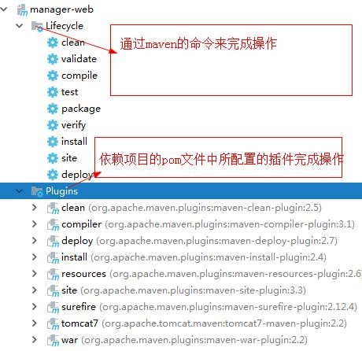

#### Tomcat 插件使用

第一种方式在子项目中配置 tomcat 插件要求所有的聚合工程必须要安装。

第二种方式在父项目中配置 tomcat 插件不要求所有的工程必须要安装。

# 实现用户添加业务

**9.1**创建业务层

**public interface** UsersService {

|  |
| --- |
| **void** addUser(Users users);  } |
| @Service  **public class** UsersServiceImpl **implements**  UsersService {  @Autowired  **private** UsersMapper **usersMapper**;  @Override  **public void** addUser(Users users) { **this**.**usersMapper**.insertUser(users);  } } |

**9.2**创建 **Controller**

@Controller **public class** PageController {

|  |
| --- |
| @RequestMapping(**"/{page}"**)  **public** String showPage(@PathVariable String  page){ **return** page;  } } |
| @Controller @RequestMapping(**"/user"**) **public class** UsersController {  @Autowired  **private** UsersService **usersService**;  @RequestMapping(**"/addUser"**) **public** String addUser(Users users){ **this**.**usersService**.addUser(users); **return "ok"**;  } } |

**9.3**创建 **Jsp**

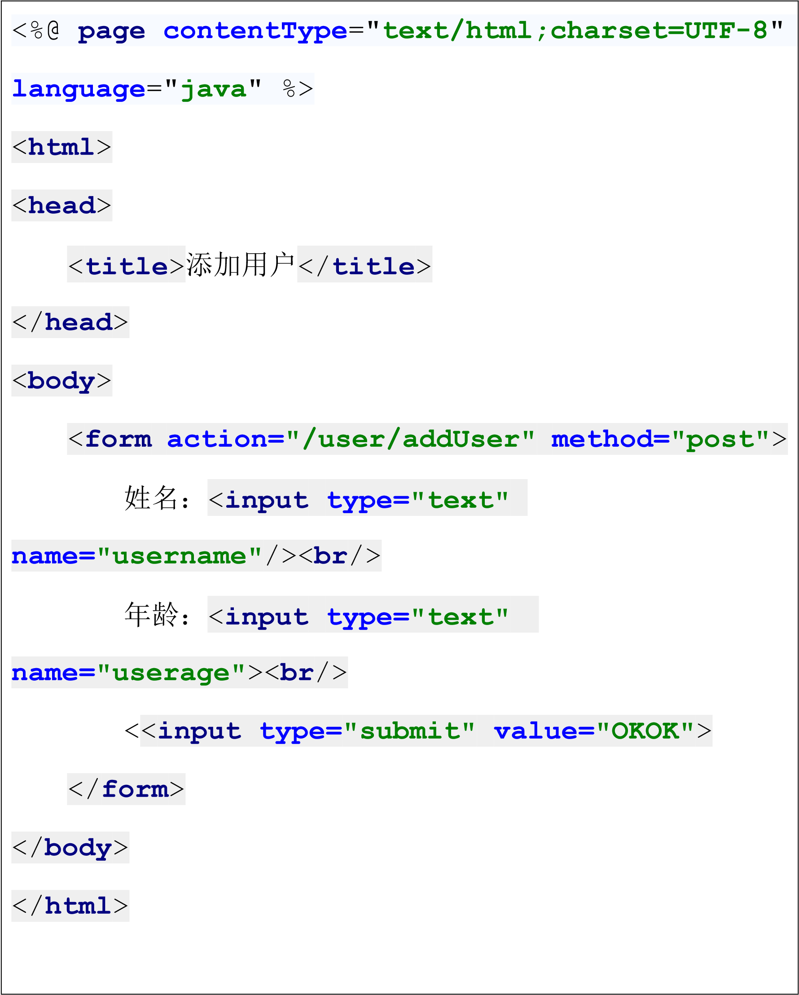

# Idea 中的项目打包

## Maven 项目的打包处理

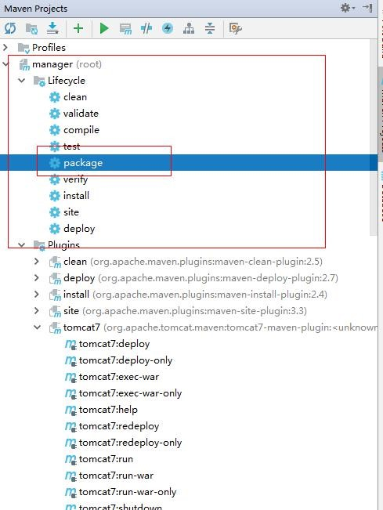

## 非 Maven 项目的打包处理

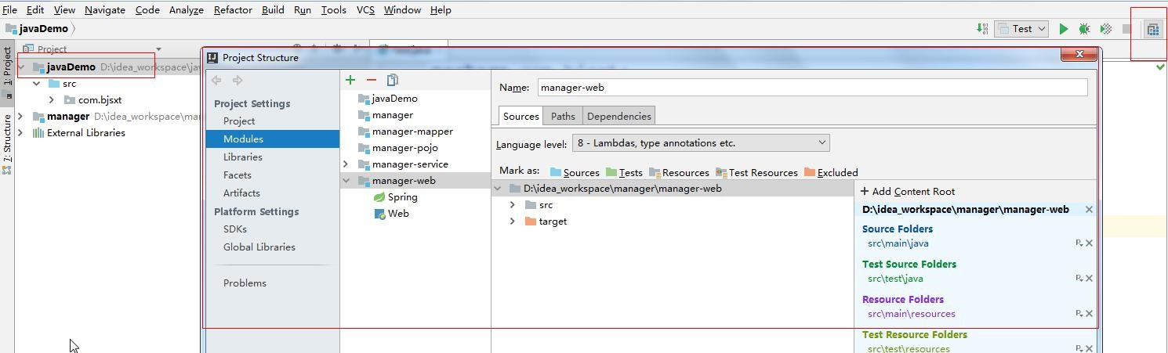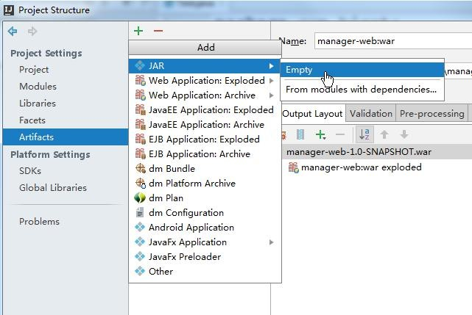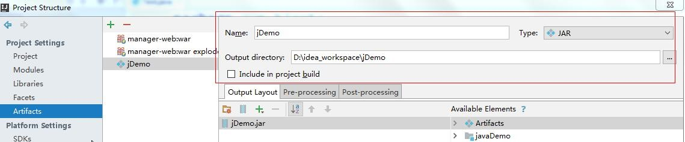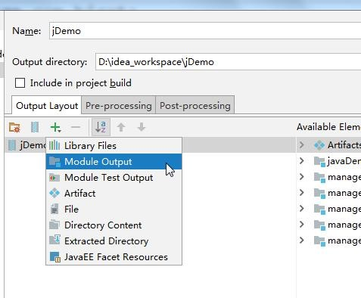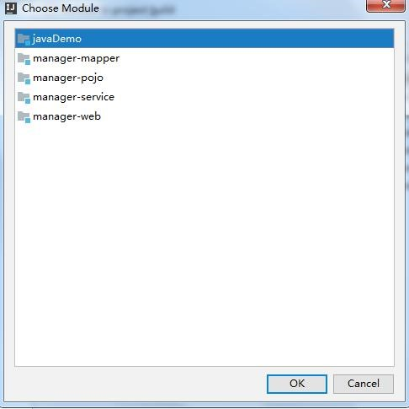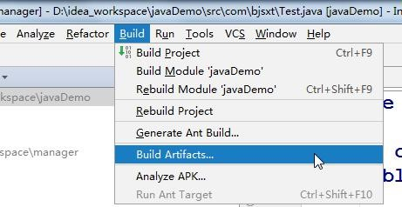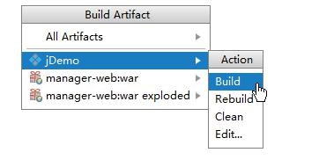

# IDEA 的其他常用功能

**1 IDEA** 中 **SVN** 的使用

**1.1**提交项目代码

## 1.1.1 上传代码时可以指定忽略一些上传目录

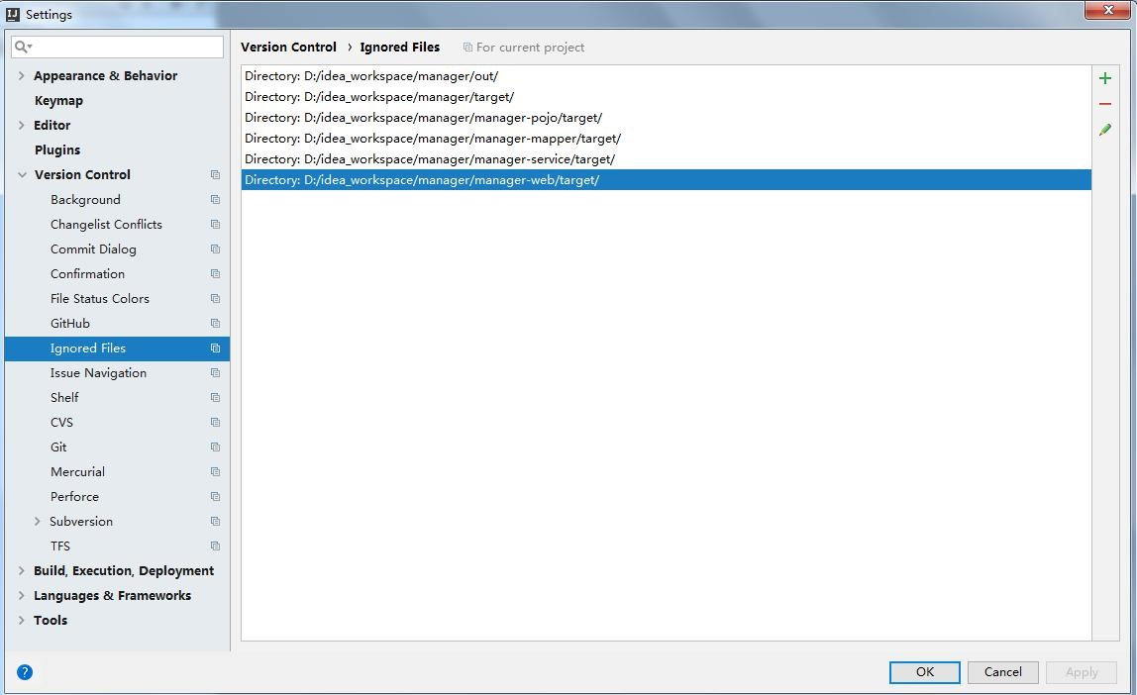

**1.1.2** 设置项目上传的路径

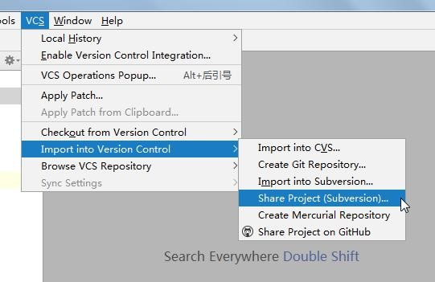

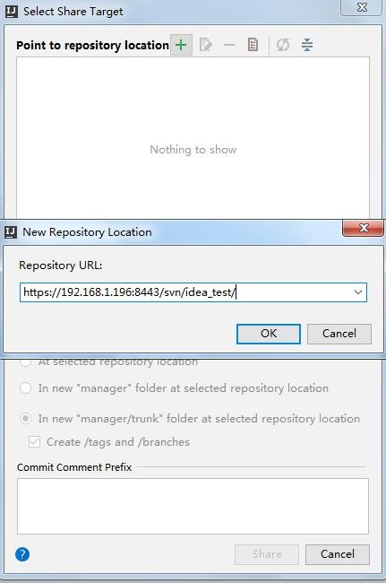

**1.1.3** 解决上传路径中包含“**svn**”目录问题

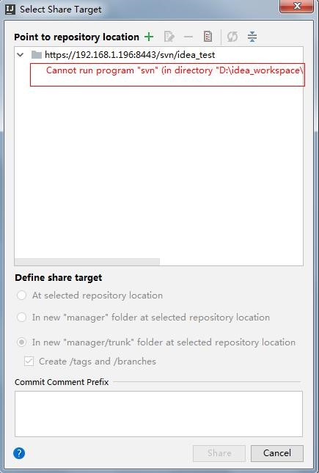

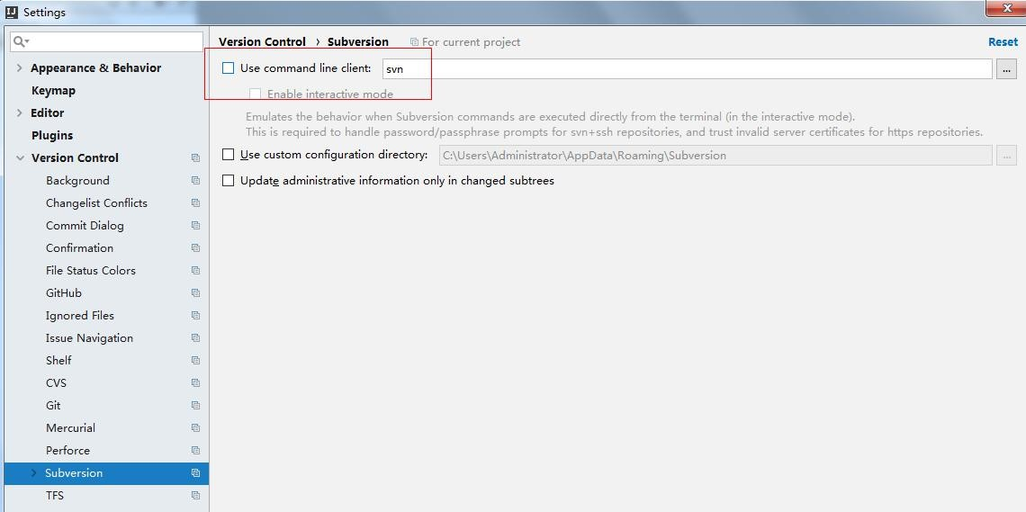

**1.1.4** 上传项目

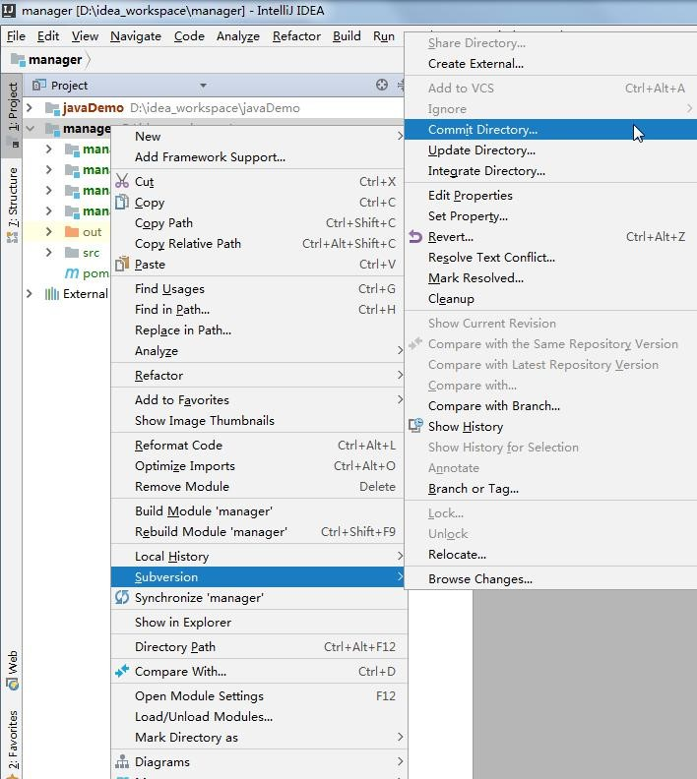

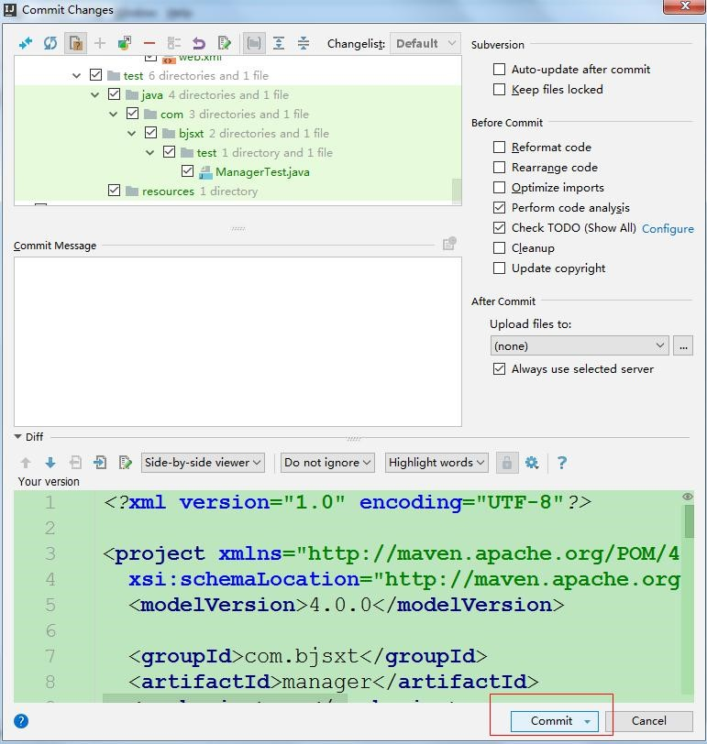

**1.2**从 **SVN** 服务器中检出代码到工作空间

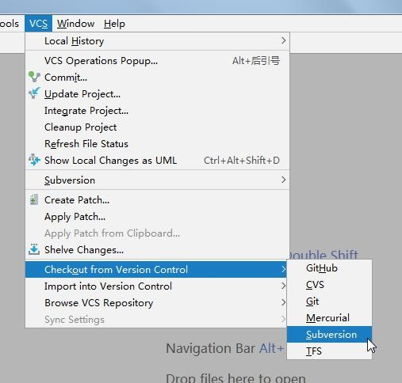

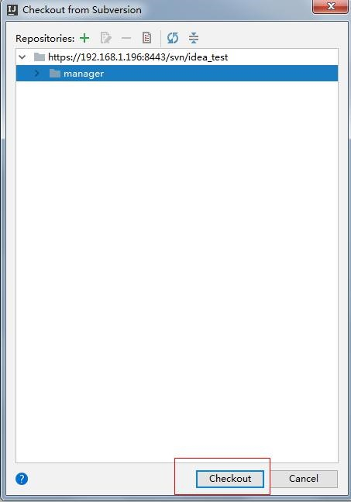

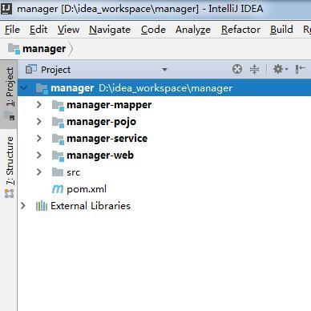

**1.3IDEA** 中 **SVN** 的基本使用

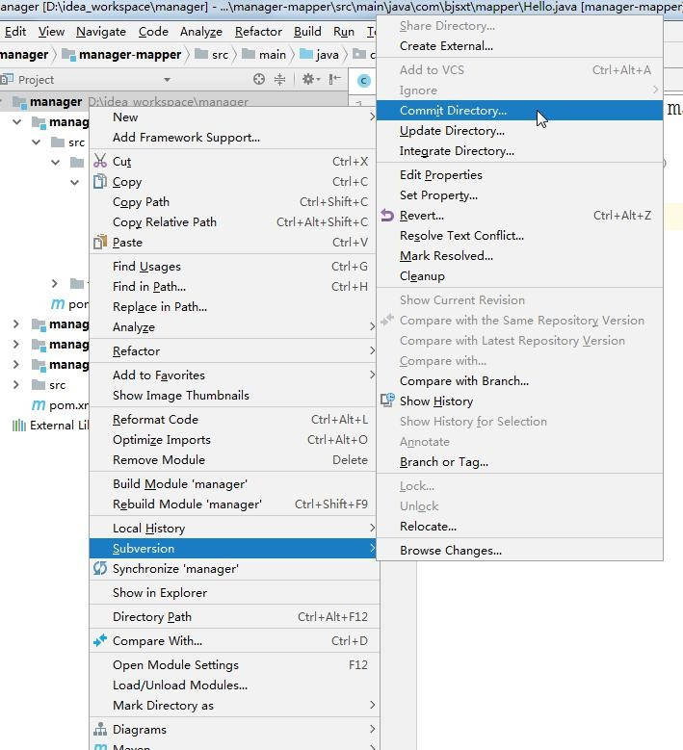

**2** 使用 **Git** 管理代码

**2.1**使用本地 **Git** 仓库管理代码

**2.1.1** 项目脱离 **SVN** 控制

**2.1.1.1** 删除**.svn** 目录

**2.1.1.2** 修改**.idea** 目录中的 **vcs.xml** 文件

**2.1.2** 创建本地 **Git** 仓库

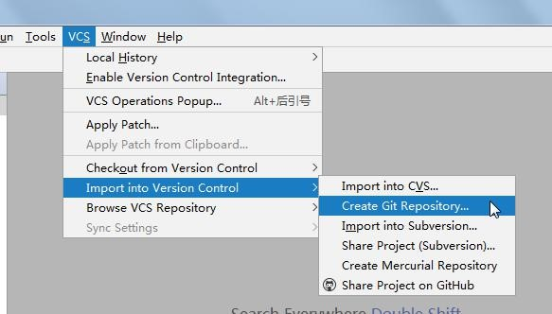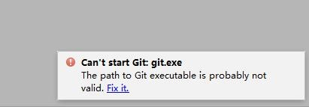

**2.1.3** 安装 **Git** 插件

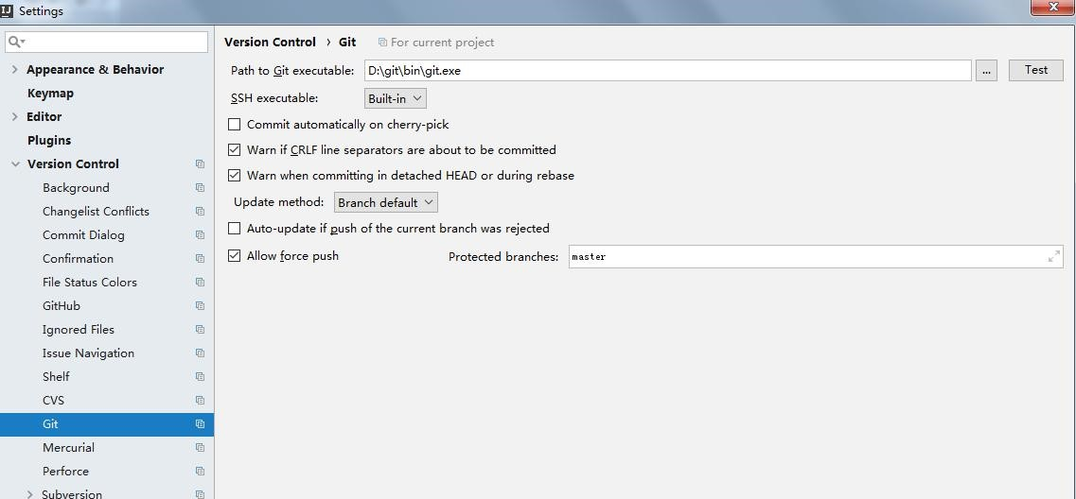

**2.1.4** 将代码添加到 **Git** 的本地仓库

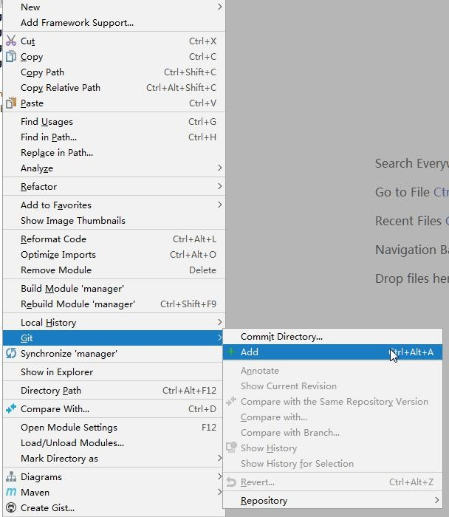

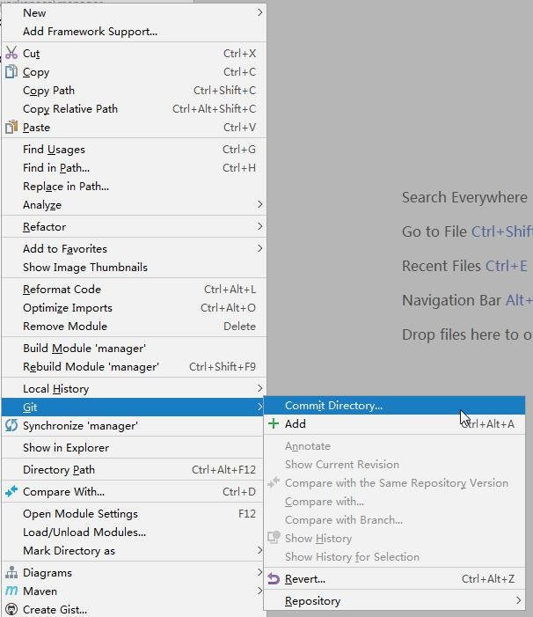

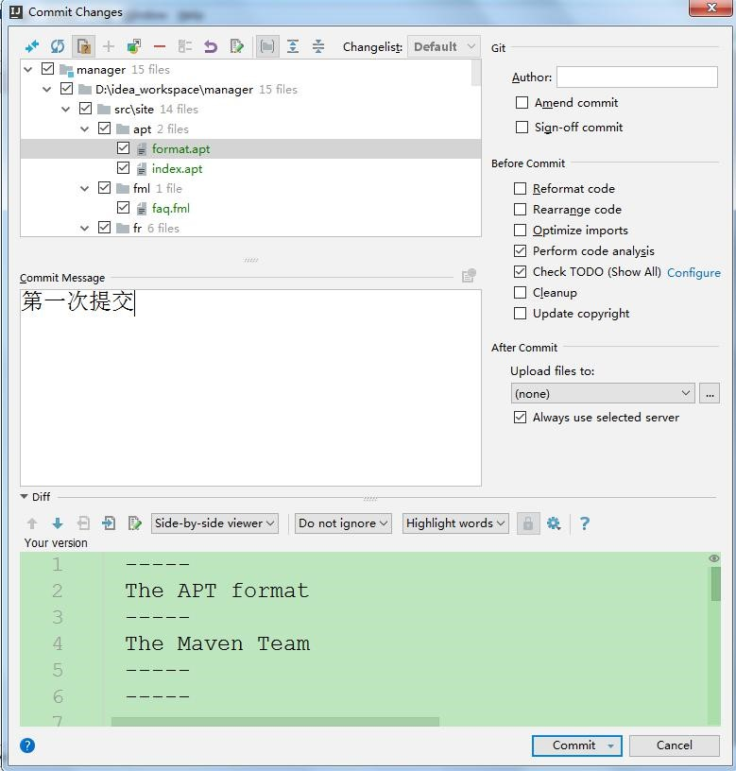

**2.2**使用 **GitHub** 远程仓库管理代码

## 2.2.1 在 GitHub 中创建仓库

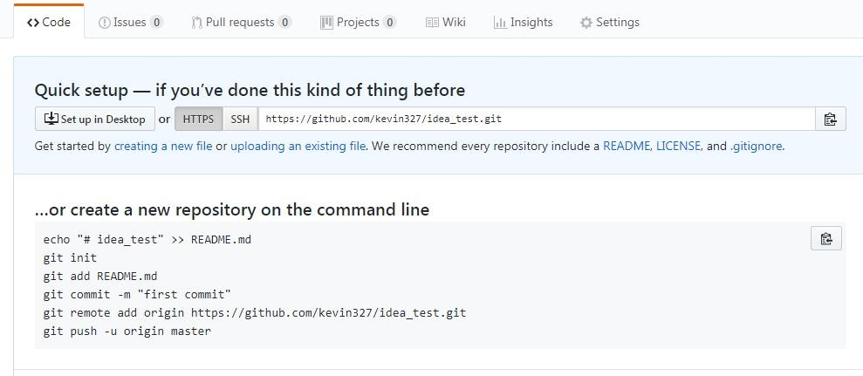

**2.2.2** 将代码上传到 **GitHub** 中

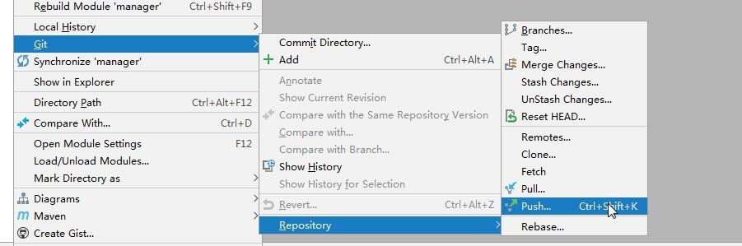

**2.2.3** 设置远程仓库地址

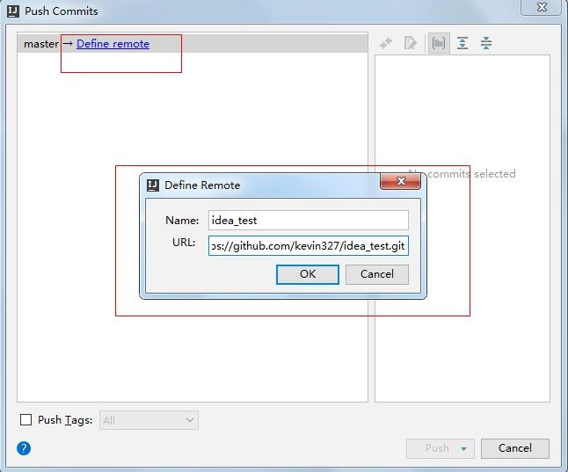

1. **IDEA** 中 **Debug** 的使用

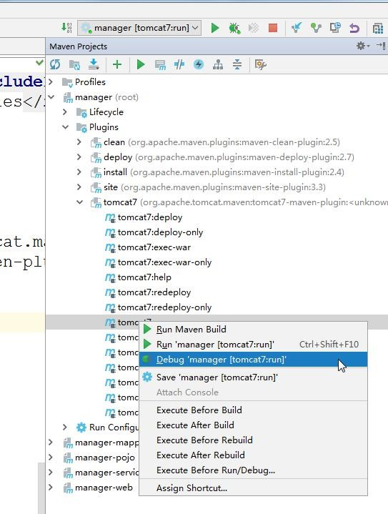

1. **IDEA** 中的 **REST Client** 工具使用

**4.1**测试代码

|  |
| --- |
| */\*\**   * *doGet*   *\*/*  @RequestMapping(value =  **"/doGet/{userid}"**,method = RequestMethod.***GET***) **public** String doGet(@PathVariable Integer userid){  System.***out***.println(**"doGet.........."**+userid); **return "ok"**;  }  */\*\**   * *doPost*   *\*/*  @RequestMapping(value = **"/doPost"**,method = RequestMethod.***POST***)  **public** String doGet(Users users){  System.***out***.println(**"doPost.........."**); System.***out***.println(users); |

|  |
| --- |
| **return "ok"**;  }  */\*\**   * *doDelete*   *\*/*  @RequestMapping(value = **"/doDelete"**,method = RequestMethod.***DELETE***)  **public** String doDelete(Integer userid){  System.***out***.println(**"doPost.........."**+userid); **return "ok"**;  }  */\*\**   * *doDelete*   *\*/*  @RequestMapping(value = **"/doPut"**,method = RequestMethod.***PUT***) **public** String doPut(){  System.***out***.println(**"doPut.........."**); **return "ok"**;  } |

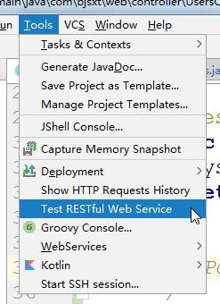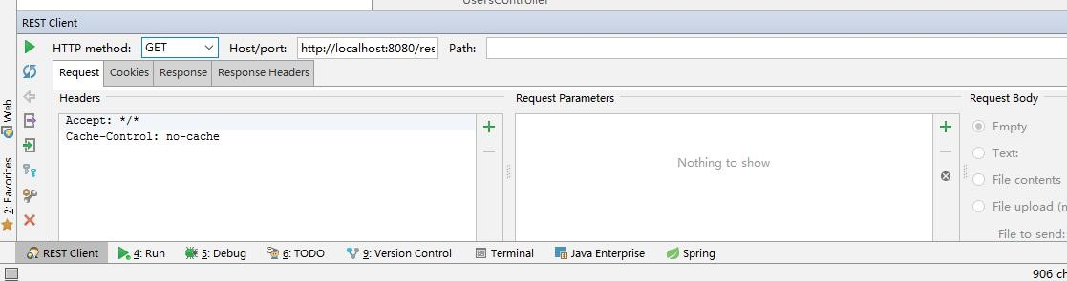

1. **IDEA** 中的 **Linux(SSH)**远程管理工具的使用

**5.1**设置 **Linux** 的链接地址

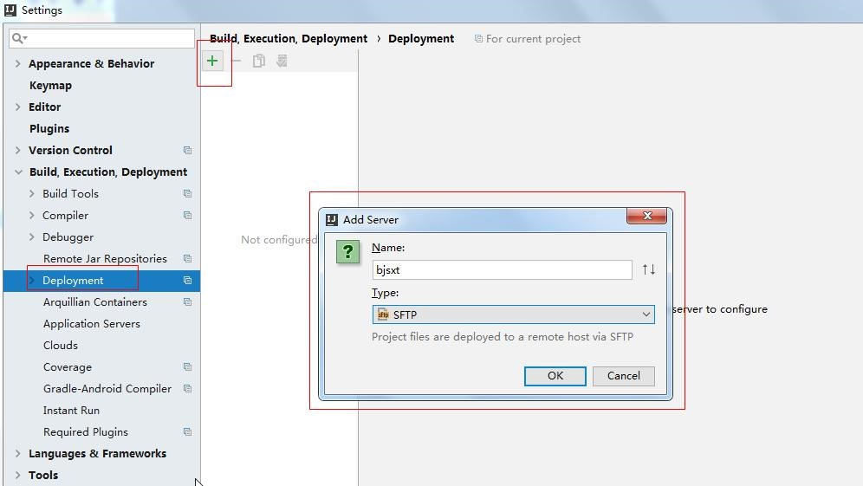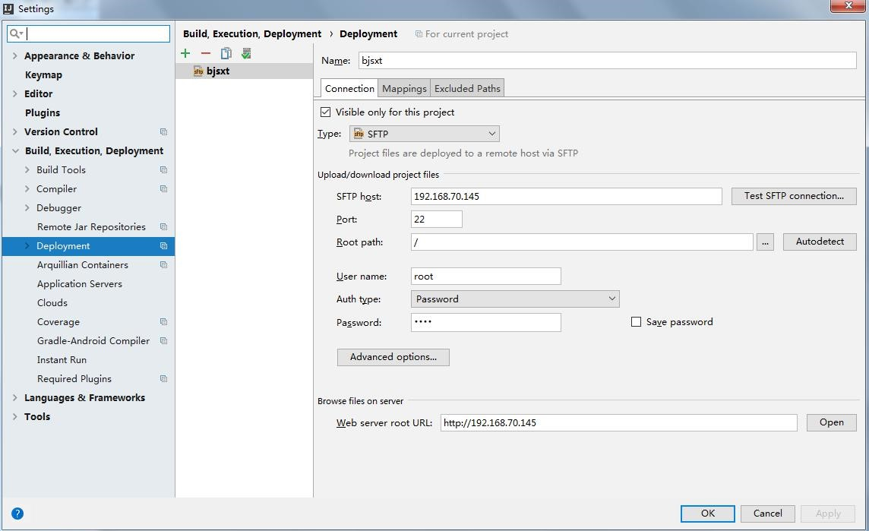

**5.2**启动 **SSH** 工具

